**KYAMBOGO**

**UNIVERSITY**

**FACULTY OF ENGINEERING**

**DEPARTMENT OF MINING, CHEMICAL AND PETROLIUM ENGINEERING**

**BACHELOR OF SCIENCE IN OIL AND GAS PRODUCTION**

**INDUSTRIAL TRAINING REPORT II**

**BY**

**SSENKIMA ASHIRAF**

**21/U/GPE/8705/PE**

**YEAR TWO**

**INDUSTRIAL TRAINING REPORT SUBMITTED IN PARTIAL**

**FULFILLMENT OF THE REQUIREMENTS FOR THE AWARD**

**OF A BACHELOR'S DEGREE IN OIL AND GAS PRODUCTION OF KYAMBOGO**

**UNIVERSITY**

**SEPTEMBER 2023**

|  |  |  |
| --- | --- | --- |
|  | 1 |  |

**DECLARATION**   
I declare that this report is my original work and has not been previously submitted for any other degree or award at Kyambogo University and other institutions. It’s based on knowledge, skills and research related to the activities done during Industrial Training at Tarn Energy Services Ltd in partial fulfillment of the requirements for the award of a Bachelor of Science in Oil and gas Production.

Signature: Date:

…………………………….

**SSENKIMA ASHIRAF**

i

**APPROVAL**

This industrial training report is the original report of **SSENKIMA ASHIRAF** and has been approved

by;

**FIELD SUPERVISORS**

MS. MWESIGWA DIANA NAKIWALA

**HUMAN RESOURCE MANAGER**

Signature ………………………………………………………

Date ………………………………………………………

**UNIVERSITY SUPERVISOR**

Ms. ANENA MAGREAT PHOEBE

Signature: **……………………**

Date**:** ..............................................

ii

**DEDICATION**   
This report is dedicated to my beloved father Mr. LUKAGO ALI, mother Mrs. BUKIRWA REHEMA and to my mentor including Haji MUSA LUDEGA MATOVU and all my field supervisors for the great support extended to me during my internship training.

iii

**ACKNOWLEDGEMENT**   
Words cannot express my gratitude to my ALLAH for enabling me to complete my industrial training successfully. I also could not have archived this without Tarn Energy Services Ltd that gave an opportunity to train.

Am deeply grateful to my, training officers Ms. Mwesigwa Diana Nakiwala, Mr. Mushumba Mark, Mr. Musiimenta Isaac, Mr. Owora Lennart, Ms. Ankunda Isabellah, Mr. Billy and others for their train, mentorship, inspection and charity they showed me.

Am also grateful to my fellow trainees Sheila, Emmasoft, Nelson among others for the love, care and support extended to me.

Lastly I thank my family members especially my Mam Bukirwa Rehema and my Dad Lukwago Ali and the HESFB for the financial support extended to me despite the unfavorable economic conditions in the country. Finally I would like to thank Eng. Kulubya Sraaj, Haaji Musa Lubega my secondary Head teacher and my aunt Nakayinga Sylvia and my best friends for their great contributions towards my success in training.

iv

**LIST OF ACRONYMS**

2D: 2 Dimension .......................................................................................................................................... 14 3D: 3 Diametion .......................................................................................................................................... 12 ANSI: American National Standards Institute .............................................................................................. 28 ASCII: American Standard Code Information Interchange ........................................................................... 13 AZIM: Azimothy ......................................................................................................................................... 13 CAD: Computer Aided Design .................................................................................................................... 45 CFR: Code of Federal Regulation ................................................................................................................ 28 CNOOC: China National Oil Company ....................................................................................................... 45 CV: Curriculum vitae..................................................................................................................................... 7 DEV: Deviation ........................................................................................................................................... 13 E&P: Energy and Power ........................................................................................................................ vii, 11 EACOP: East African Crude Oil Pipeline .................................................................................................... 45 ED: European Datum1950 ........................................................................................................................... 13 Eng: Engineer ...............................................................................................................................................iv g nuts: ground nuts ........................................................................................................................................ 7 **GIS: Geological Information systems** ....................................................................................................... 17 HESFB: Higher Education Student Financing Board ....................................................................................iv HR: Human Resource .................................................................................................................................. 23 HSE: Healthy Safety and Environment .......................................................................................................... 7 INCL: Inclination ........................................................................................................................................ 13 ISEA: Intentional Safety Equipment Association ......................................................................................... 28 KB: Kelly Bushing ...................................................................................................................................... 13 KPIs: Key Performance Indicator ................................................................................................................ 40 Ltd: Limited................................................................................................................................................... i MD: Measured Depth .................................................................................................................................. 13 ML: Machine Learning ................................................................................................................................ 17 Mr: Mister ................................................................................................................................................... 29 Ms: Miss ...................................................................................................................................................... 37 NaOH: Sodium Hydroxide ............................................................................................................................. 9 NFPA: National Fire Protection Association ................................................................................................ 28 NIOSH: National Institute for Occupational Safety and Healthy .................................................................. 28 PASS: Pull Aim Squeeze and Sweed ........................................................................................................... 32 PAU: Petroleum Authority of Uganda.......................................................................................................... 23 PFAS: Personal Fall Arrest Systems ............................................................................................................ 29 PPE: Personal Protective Equipments .......................................................................................................... 29 **PTO: Plastics to oil** ...................................................................................................................................... 8 RFPs: Required for proposals ...................................................................................................................... 41 SDS: Safety Data Sheets .............................................................................................................................. 25 seg: segregation ........................................................................................................................................... 16 slb: Schlumberger ........................................................................................................................................ 23 SOPs: Standard Operation Procedures ......................................................................................................... 25 SRLs: Self Retracting Lanyards .................................................................................................................. 29 TD (MD): True Depth and Measured Depth ................................................................................................. 13 TMT: This is the mining company ............................................................................................................... 42

v

UTM: Universal Transverse Mercator coordinate system ............................................................................. 13 WBS: Work Breakdown Structure ............................................................................................................... 40

vi

**TERMINOLOGIES**   
**Pyrolysis** is a thermal decomposition process that breaks down organic materials into smaller molecules in the absence of oxygen. This process is used to convert a variety of materials into useful products, such as fuels, chemicals, and fertilizers.

**Petrel software** is a subsurface software platform used in the exploration and production (E&P) sector of the petroleum industry. It was developed by Techno guide, a Norwegian company, and was first released in 1998. Petrel is now owned and developed by Schlumberger, a leading oilfield services company.

**Risk** is the degree of likelihood on which harm may be caused.

**Hazard** is anything that has a potential to cause harm.

**First aid** is the first help given to a person who has just got injury.

**Wells**: A well is an excavation or opening in the ground that is created to access a subsurface resource such as water, oil, or gas. Wells are typically drilled using a drill rig, and they can be either vertical or horizontal.

**Bidding**: Bidding is the process of submitting a proposal for a project or contract. The bidder typically provides a price and other information about how they will complete the project. The winning bidder is the one who submits the most competitive proposal.

**CV**: A CV (curriculum vitae) is a document that summarizes your education, work experience, skills, and other qualifications. It is used to apply for jobs and other opportunities.

**Resume:** A resume is a document that summarizes your work experience, education, and skills. It is typically shorter and more concise than a CV.

**Reservoi**r: A reservoir is a natural underground formation that contains oil, gas, or water. Reservoirs are typically created by the accumulation of fluids over time.

vii

**Accident**: An accident is an unplanned and unexpected event that causes injury or damage. Accidents

can happen in any setting, including the workplace.

**Incident**: An incident is an event that could have caused injury or damage, but did not. Incidents are

important to report because they can help to prevent accidents from happening in the future.

**Helmets**: A helmet is a protective headgear that is worn to protect the head from injury. Helmets are

typically made of hard materials such as plastic or metal, and they have a chin strap to keep them in place.

**Safety**: Safety is the state of being safe from harm or danger. Safety is important in all aspects of life,

including the workplace.

**Arrestors**: An arrestor is a device that is used to stop or slow down a moving object. Arrestors are

typically used in safety applications, such as to prevent falls or to protect equipment from damage.

**Project**: A project is a temporary endeavor that is undertaken to achieve a specific goal. Projects can be

small or large, simple or complex.

**Magnetometer**: A magnetometer is a device that measures the magnetic field of the Earth.

Magnetometers are typically used in scientific research, but they can also be used in safety applications,

such as to detect the presence of magnetic fields.

**Gravimeter**: A gravimeter is a device that measures the force of gravity. Gravimeters are typically used

in scientific research, but they can also be used in safety applications, such as to detect the presence of

underground cavities.

**Events**: An event is something that happens. Events can be planned or unplanned, and they can be large

or small.

**Achievements**: An achievement is something that you have accomplished. Achievements can be big or

small, and they can be personal or professional.

**Modeling**: Modeling is the process of creating a representation of something. Models can be used to

understand or predict the behavior of something.

viii

**Employee**: An employee is a person who works for an employer. Employees typically receive a salary or wage in exchange for their work.

**Employer**: An employer is a person or organization that hires employees. Employers typically provide their employees with a place to work, equipment, and training.

**Appendices**: Appendices are additional materials that are included at the end of a document.

ix

**TABLE OF CONTENTS**

**DECLARATION** ......................................................................................................................................... i **APPROVAL** ................................................................................................................................................ ii **DEDICATION** ........................................................................................................................................... iii **ACKNOWLEDGEMENT** ..........................................................................................................................iv **TERMINOLOGIES** .................................................................................................................................. vii **LIST OF FIGURES** .................................................................................................................................. xii **ABSTRACT** ............................................................................................................................................. xiii **1.1 Background.** ....................................................................................................................................... 1 **1.2 Mission** ................................................................................................................................................ 1 **1.3 Vision** .................................................................................................................................................. 1 **1.4 Location** .............................................................................................................................................. 1 1.5 **OBJECTIVES OF TARN ENERGY SERVICES LTD** ............................................................... 2 **1.4. ORGANIZATIONAL STRUCTURE OF TARN ENERGY SERVICES LTD** .............................. 3 **1.5. ORGANIZATION CHART DISCUSSION** ..................................................................................... 4 **1.5.1. Board of Directors** ...................................................................................................................... 4 **1.5.2. Managing Director** ..................................................................................................................... 4 **1.5.3. Finance Manager.** ....................................................................................................................... 4 **1.5.4. Human Resource Manager ETC.** ............................................................................................... 5 **1.6. OBJECTIVES OF INDUSTRIAL TRAINING** ............................................................................... 5 **CHAPTER TWO** ......................................................................................................................................... 7 **ACTIVITIES**................................................................................................................................................ 7 **1.0. INTRODUCTION** ......................................................................................................................... 7 **2.1.0**  **PYROLYSIS.** .......................................................................................................................... 7 **2.1.1 PTO** .............................................................................................................................................. 8 **2.1.2 Budget** .......................................................................................................................................... 9 **2.1.3 Project experiment.** ................................................................................................................... 10 **2.2.0 INDUSTRIAL SOFTWARE** ..................................................................................................... 11 **2.2.1 Petrel software** ........................................................................................................................... 11 **2.2.2 ArcGIS** ....................................................................................................................................... 17 **Arc map** .............................................................................................................................................. 18 **Google Earth** ...................................................................................................................................... 22 **2.3.0 WORKPLACE SKILLS** ........................................................................................................... 23 **2.3.1 CV and resumes** ......................................................................................................................... 23

x

**2.3.2 Bidding** ....................................................................................................................................... 23 **2.3.3 Research tools** ............................................................................................................................ 24 **2.4.0 HSE** ............................................................................................................................................ 24 **2.4.1 Hazard identification and risk analysis** .................................................................................... 24 **2.4.2 Personal protective equipment** .................................................................................................. 27 **2.4.3 Emergency response** .................................................................................................................. 29 **2.4.4 Fire safety** .................................................................................................................................. 32 **2.4.5 12 golden rules in HSE** .............................................................................................................. 36 **2.5.0 PROJECT MANAGEMENT** .................................................................................................... 37 **2.5.1 Organization structure of project management.** ...................................................................... 37 **2.5.2 The role of project manager** ...................................................................................................... 39 **2.5.3 PROJECT PLANING** ............................................................................................................... 40 **2.5.4 Project planning.** ....................................................................................................................... 43 **RESULTS AND DISCUSSIONS** ............................................................................................................... 47 **CHAPTER FOUR**...................................................................................................................................... 49 **ACHIEVEMENTS AND CHALLENGES FACED** ................................................................................. 49 **4.0. INTRODUCTION** ........................................................................................................................... 49 **4.1. ACHIEVEMENTS** .......................................................................................................................... 50 **4.2. CHALLENGES FACED** ................................................................................................................. 50 **CHAPTER FIVE** ....................................................................................................................................... 52 **RECOMMENDATION AND CONCLUSION** ......................................................................................... 52 **5.1. RECOMMENDATIONS** ................................................................................................................ 52 **5.2. CONCLUSION** ................................................................................................................................ 52 **REFERENCES** .......................................................................................................................................... 54 **APPENDICES** ............................................................................................................................................ 55

xi

**LIST OF FIGURES**

Figure 1: shows the gas oil produced after the project experiment. ............................................................... 10 Figure 2: shows part of our group members in group three for production of gasoline project. ..................... 11 Figure 3: Picture of 2D of wells in petrel software. ...................................................................................... 14 Figure 4: shows 3D wells in the petrel software with the axis that help us to determine the distance between wells. ........................................................................................................................................................... 14 Figure 5: shows the wells viewed in well selection window. ........................................................................ 15 Figure 6: shows global wells and well tops. .................................................................................................. 16 Figure 7: shows the interpreted seismic data with named faults and horizons viewed in interpretation window. .................................................................................................................................................................... 17 Figure 8: shows the ArcGIS interface. .......................................................................................................... 19 Figure 9: shows the map of Uganda in arc map. ........................................................................................... 20 Figure 10: shows the named districts in Uganda. .......................................................................................... 20 Figure 11: shows a clipped map of Ssembabule district from Uganda........................................................... 21 Figure 12: shows the map with labeled features in ArcGIS software. ........................................................... 22 Figure 13: shows the CTF grounds of Kyambogo University obtained from using google earth. .................. 22 Figure 14: shows the assemble on the fire point after fire arm was started. ................................................... 30 Figure 15: shows emergence response. ......................................................................................................... 31 Figure 16: shows the way we did while extinguishing fire. ........................................................................... 34 Figure 17: shows first aid experiment. .......................................................................................................... 36 Figure 18: shows Tarn Energy Executive committee captured during exposition day. .................................. 46 Figure 19: shows the closing party when we were cutting cake with the chief guest. .................................... 46 Figure 20: shows Tarn Energy team with their trainees captured during exposition day too. ......................... 55 Figure 21: Mr Musisi Norbert the CEO of Tarn Energy was giving advice to trainees during launch day. .... 56 Figure 22: shows the certificate I got after the training. ................................................................................ 56 Figure 23: show me holding the certificate. .................................................................................................. 57 Figure 24: one of my team members during the training and was also captured during exposition day. ........ 58 Figure 25: During awarding certificates, the lady was a chief guest from EACOP and the other guest was from Victoria University. ..................................................................................................................................... 59 Figure 26: Was captured during our gasoline experiment. ............................................................................ 60

xii

**ABSTRACT**   
The purpose of this report is to provide a comprehensive overview of activities we had in the session as pyrolysis, workplace skills, HSE, project management industrial software and events. The report will discuss the current state of each activity, the challenges, and the future trends that are expected to shape each field. The report found that pyrolysis is a promising technology for the disposal of waste materials and the production of renewable energy. However, there are still some challenges that need to be addressed, such as the high cost of equipment and the need for further research. The report also found that workplace skills are essential for employees to perform their jobs effectively. However, there is a skills gap in many industries, and employers are struggling to find qualified workers. The report found that health, safety and environment (HSE) is a critical issue for businesses. Companies need to implement effective HSE practices to protect their employees, customers, and the environment. The report found that project management is a complex and challenging task. However, it is essential for businesses to successfully achieve their goals. The report found that events are an important way for businesses to connect with their customers and stakeholders. However, event planning can be a daunting task, and businesses need to carefully plan and execute their events.

The report concludes that pyrolysis, workplace skills, health safety and environment, project management and events are all important activities that play a vital role in the economy. The report provides recommendations for how each activity can be improved and developed in the future.

xiii

**CHAPTER ONE**

**CHAPTER ONE INTRODUCTION**

**1.1 Background.**

Tarn Energy Services Ltd (TESL) located on plot 96A Old Kira Road, Ntinda is a Ugandan company incorporated in 2020 fully registered with URSB **(80020002641664),** on the National supplier data base **(NSD-13273/2021/2253)** with PAU and the Uganda Revenue Authority **(TIN:1017068273).**

Tarn Energy is comprised of a team of diversely skilled consultants & personnel with over 10 years of experience in the industry. We offer consultancy services in Oil and Gas, Health Safety and Environment, supplies and logistics as well as Engineering and construction services.

Since inception, creation of an HSE culture in all our work has been our theme, both within and externally. We are achieving this through development and insemination of highly effective and Innovative HSE solutions and products to our clients.

Our outstanding reputation is based on quality and reliability of services provided.

We are ISO certified and accredited by the Ministry of Education, Games and Sport through its arm, Directorate of Industrial Training to offer a wide range of professional trainings across different sectors not limited to HSE.

**1.2 Mission**   
To provide profound services which add value to our client's integrity and the general development of the energy sector and extractive industry for sustainability

**1.3 Vision**   
To be the leading provider of quality, reliable and excellent training, consultancy and construction services in the energy sector and extractive industry within the region

**1.4 Location**   
 Tarn Energy Services Ltd is located in Ntinda, Old Kira Road Plot 96A Kira Rd, Kampala and is 2.8 km from Kampala - Jinja Road from Nakawa.

1

1.5**OBJECTIVES OF TARN ENERGY SERVICES LTD**

➢Provide quality consultancy services and trainings in HSE, electrical and civil construction

engineering works, Oil and gas and Renewable energy

➢Contribute to the sustainable and economic development of the energy sector through fostering

meaningful collaborations

➢Strengthen the capacity of industry professionals through customized HSE trainings; and promote

access to resources and opportunities in the oil and gas industry.

➢Support the energy sector through our diverse engineering and construction services, that meet the

requirements of the industry

2

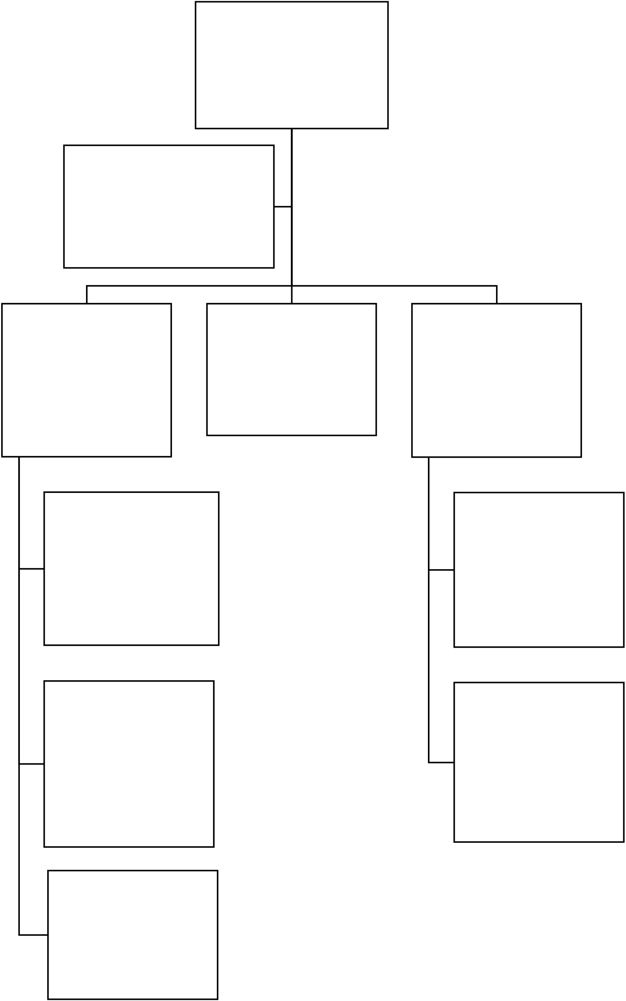

**1.4. ORGANIZATIONAL STRUCTURE OF TARN ENERGY SERVICES LTD**

**CEO**

**Mr. Musisi Norbert**

**GENERAL MANAGER**

Mr. Ochan Aaron

|  |  |  |
| --- | --- | --- |
| **OPERATIONS MANAGER** | **FINANCIAL MANAGER** | **HUMAN RESOURCE MANAGER** |
| Ms. Mwesigwa Diana |
| Ms. Mwesigwa  Diana |
| Mr. Namara Samuel |

**BUSINESS**   
**DEVELOPMENT**   
**MANAGER**

Mr. Owora Lennart

**ADMINISTRATIVE**   
**EXECUTIVE**

Ms. Ankunda   
Isabellah

|  |  |
| --- | --- |
| **ICT MANAGER** | **TRAINING &**  **MARKETING LEAD** |

Mr. Nabongho Ivan

**PROJECT**

**MANAGER**

Ms. Nansamba   
Patricia

|  |  |
| --- | --- |
| Mr. Kirunda Andrew | 3 |

**1.5. ORGANIZATION CHART DISCUSSION**

**1.5.1. Board of Directors**

Board of directors: The board of directors is responsible for the overall governance of the organization.

They may discuss topics such as strategic planning, financial performance, and risk management.

The board of directors is discussing the strategic plan for the next year. They are debating whether to

focus on expanding into new markets or investing in new products.

The board of directors is reviewing the financial statements for the past quarter. They are concerned about

the rising costs and are looking for ways to cut expenses.

The board of directors is meeting with the CEO to discuss the recent security breach. They are asking

questions about how the breach happened and what steps are being taken to prevent it from happening

again.

**1.5.2. Managing Director**

Managing director: The managing director is responsible for the day-to-day operations of the

organization. They may discuss topics such as sales, marketing, and product development.

The managing director is meeting with the sales team to discuss the upcoming quarter's goals. They are

reviewing the sales pipeline and discussing strategies for closing more deals.

The managing director is meeting with the marketing team to discuss the launch of a new product. They

are brainstorming ideas for how to generate awareness and excitement for the product.

The managing director is meeting with the product development team to discuss the roadmap for the

next year. They are discussing new features and functionality that they want to add to the product.

**1.5.3. Finance Manager.**

Finance manager: The finance manager is responsible for the financial health of the organization. They

may discuss topics such as budgeting, forecasting, and cash flow management.

4

The finance manager is meeting with the accounting team to review the monthly financial statements. They are looking for any areas where costs can be cut.

The finance manager is meeting with the CFO to discuss the budget for the upcoming year. They are discussing how to allocate resources to different projects.

The finance manager is meeting with the investment banker to discuss the company's options for raising capital. They are considering a stock offering or a debt offering.

**1.5.4. Human Resource Manager ETC.**

Human resource manager: The human resource manager is responsible for the people side of the organization. They may discuss topics such as recruitment, training, and compensation.

The human resource manager is meeting with the recruiting team to discuss the company's hiring goals for the next quarter. They are discussing which positions need to be filled and how to attract top talent.

The human resource manager is meeting with the training team to discuss the company's training curriculum. They are discussing how to keep employees up-to-date on the latest skills and technologies.

The human resource manager is meeting with the compensation team to discuss the company's salary and benefits packages. They are making sure that the company is competitive with other companies in the industry.

**1.6. OBJECTIVES OF INDUSTRIAL TRAINING**   
Industrial training is a valuable experience that can help students to develop their skills and knowledge, network with professionals, and make informed decisions about their careers.

Provide students with the opportunity to apply their theoretical knowledge to real-world situations. This helps students to understand how their coursework applies to the workplace and to develop the skills and knowledge they need to be successful in their careers.

Help students to develop their professional skills and knowledge. This includes skills such as problem-solving, teamwork, communication, and time management.

5

Give students the opportunity to network with professionals in their field. This can help students to learn about job opportunities and to make connections that could help them in their careers.

Help students to decide if a particular career is a good fit for them. By getting hands-on experience, students can learn more about the day-to-day tasks and responsibilities of a particular job and to see if it is something they are interested in.

Help students to develop their soft skills. These are the skills that are not directly related to a particular job, but are still important for success in the workplace. Soft skills include things like communication, teamwork, and problem-solving.

Help students to gain a competitive edge in the job market. Industrial training can give students a valuable edge over other job seekers, as it shows that they have practical experience and the skills and knowledge that employers are looking for.

6

**CHAPTER TWO**

**ACTIVITIES**

**1.0.**  **INTRODUCTION**   
Activities accomplished were, making natural gasoline from plastics, making Bio diesel from g nuts, and making briquettes via our respective groups as our projects. We had Hazard identification, fire safety, emergency evacuation, first aid, personal protective equipment awareness, and 12 golden rules in HSE. Project plan, project management structures and rules, and clear overview of project management. Installing industrial software like petrel and ArcGIS software. Using Kobo toolbox and google forms for making online questioners, writing CV and resumes, engaging in a bid and learning workplace skills.

Those are some of the activities accomplished during the session and we were led by Madam Mwesigwa Diana Nakiwala, Ms Isabella, Mr Billy for workplace skills, Mr Musisi Norbert, Mr Mushumba Mark for industrial softwares. Ms Nansamba Patricia for project management and Mr Lenat Owora, Mr Musimenta Isaac for HSE. Both were competent and were there for us

On our projects, they were Three projects we had and we were in group respectively were my group was to have the pyrolysis project. This project required us to make natural gasoline from plastics were we get the materials and we successfully completed and project. The next group was group one which was to make Bio diesel from ground nuts and they also used there materials and successfully completed their project. The last group which was group two had to make briquettes from cow dang, cassava flour, candle wax, charcoal dust, clay, and banana peelings and their project was also successful. All those projects were to sustain the use of renewable energy like the one for briquettes was to reduce the cutting of trees and to have a last longer charcoal burn because of the mixture of clay and cow dang in the briquettes. As me I was among the group three trainees were we had pyrolysis and am going to go deep in pyrolysis.

**2.1.0PYROLYSIS.**

Pyrolysis is a thermal decomposition process that breaks down organic materials into smaller molecules in the absence of oxygen. This process is used to convert a variety of materials into useful products, such as fuels, chemicals, and fertilizers.

The one we did was for production of fuel and this is the background.

7

**2.1.1 PTO**   
The use of pyrolysis to make gasoline from plastics is a relatively new development. The first commercial plant to produce gasoline from plastic waste was built in 2012 in the Netherlands. This plant uses a process called "plastic to oil" (PTO) to convert plastic waste into a liquid fuel that can be used in gasoline engines.

The PTO process involves heating plastic waste to high temperatures in the absence of oxygen. This causes the plastic to break down into smaller molecules, including hydrocarbons. These hydrocarbons can then be refined to produce gasoline.

The PTO process has several advantages over traditional gasoline production. First, it can be used to convert plastic waste into a valuable fuel. This helps to reduce the amount of plastic waste that ends up in landfills or incinerators. Second, the PTO process is a relatively clean process that produces few emissions. This makes it a more sustainable alternative to traditional gasoline production.

However, the PTO process also has some disadvantages. First, it is a relatively expensive process. This is due to the high cost of the equipment and the energy required to heat the plastic waste. Second, the PTO process produces a variety of byproducts, including char and syngas. These byproducts need to be disposed of or recycled, which can add to the cost of the process.

These are some of the reasons on why we converted PTO

Plastic waste is a major environmental problem. It pollutes our oceans, waterways, and landfills. It can also harm wildlife and humans. According to the World Economic Forum, plastic pollution costs the global economy \$13 billion per year. Producing gasoline from plastics can help to reduce the amount of plastic waste that ends up in the environment.

Gasoline is a fossil fuel, and its production contributes to climate change. Burning gasoline releases greenhouse gases into the atmosphere, which trap heat and cause the planet to warm. Producing gasoline from plastics can help to reduce our reliance on fossil fuels and create a more sustainable fuel source.

The United States is currently the world's largest producer of oil, but our oil reserves are finite. We import about 40% of our oil from other countries. This makes us vulnerable to supply disruptions and price

8

volatility. Producing gasoline from plastics can help to create a more secure fuel supply for the United States.

Currently, most plastic waste is either landfilled or incinerated. Landfilling plastic waste contributes to methane emissions, a potent greenhouse gas. Incineration of plastic waste releases harmful pollutants into the air. Producing gasoline from plastics can create a new market for plastic waste, which can help to reduce the amount of plastic waste that is sent to landfills and incinerators.

During the project, we created the budget and then we discussed in our group about that budget and it was altered as shown in the table below. The budget included all the materials and equipment we used and the amount of money we used to buy the materials.

**2.1.2 Budget**   
Next was to organize the materials and equipment we used and plastics were the basic materials to obtain the gasoline and we cut the plastic into pieces. The metallic Drum was to collect the pieces of plastics and then we connected the condenser to the metallic Drum we sealed the connection with rubber. The condenser is connected with the small tube that provides hydrogen gas that mixes with the fuel vapor from the metallic Drum and the collector we used was the plastic bottle were we collected a litter of gas oil. We organized the cooking space and we used match box to light the stove and we also used to add more firewood for temperature maintenance. The drum was placed in a slanting position for easy collection of gas oil. The cooler we used was manual cooler were we socked the towel in water and we used that wet towel to cool the condenser pipe as shown below.

|  |  |  |  |
| --- | --- | --- | --- |
| **ITEM** | **DESCRIPTION** | **QUANTITY** | **AMOUNT** |
| Plastics | Raw materials | 1 | UGX 7,500 |
| Metallic drum | Boiling plastics | 5kg | UGX 65,000 |
| Condenser | Cooling plastics | 1 | UGX 0 |
| NaOH Pillets | Reacting to produce Hydrogen gas | 5g | UGX 5,000 |
| Aluminum | Producing hydrogen gas | 4g | UGX 0 |
| Transport | Transport and extra cost average |  | UGX 10,000 |
| Collection vessel | Collecting gas oil | 2 | UGX 0 |
| Match box | Lighting | 1 | UGX 0 |

9

|  |  |  |  |
| --- | --- | --- | --- |
| Rubber horse | Transferring hydrogen to the metallic pipe | 1 | UGX 0 |
| Firewood | Source of heat | 1 | UGX 10,000 |
| Metallic pipe | Transporting vaporized gas oil | 1 | UGX 45,000 |
| **TOTAL** |  |  | **UGX 142,500** |

**2.1.3 Project experiment.**

During the project the supervisors were Ms Mwesigwa Diana Nakiwala, Ms Isabella, Mr Billy and and

Mr Javiira. The project was successful because of Mr Billy who had a prior knowledge about pyrolysis

and he was there to guide us.

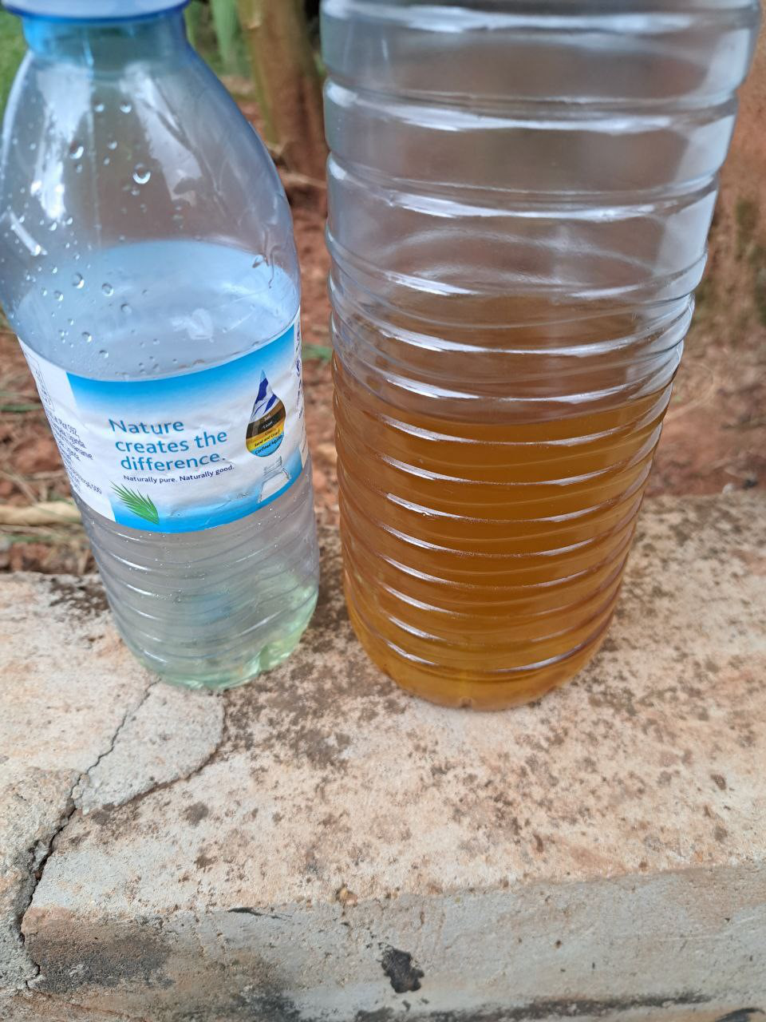

*Figure 1: shows the gas oil produced after the project experiment.*

10

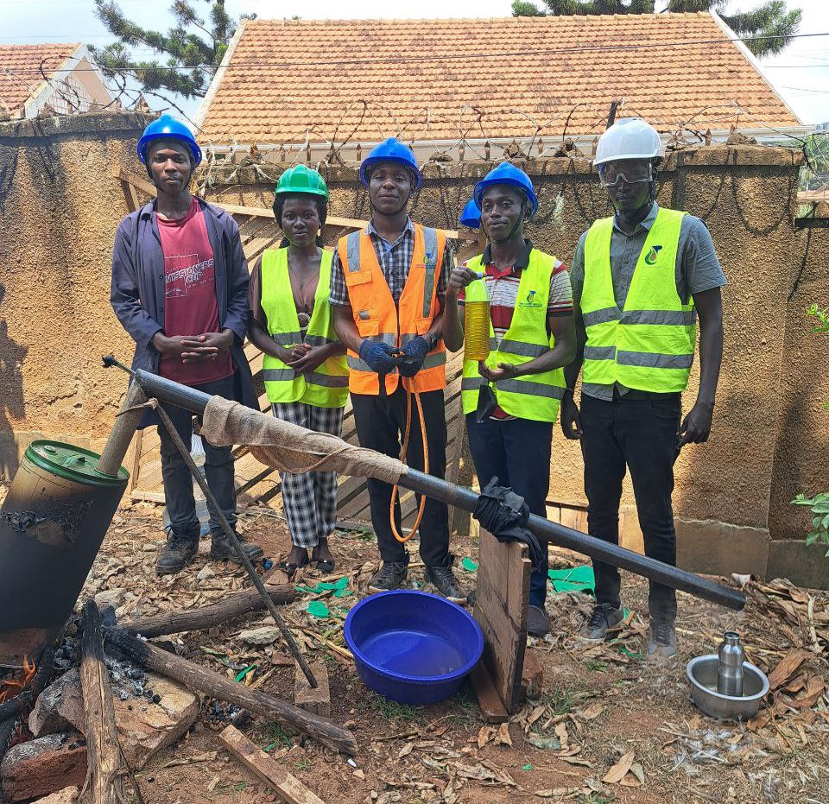

*Figure 2: shows part of our group members in group three for production of gasoline project.*

**2.2.0 INDUSTRIAL SOFTWARE**   
Next was about industrial software such as petrel software and ArcGIS software.

**2.2.1 Petrel software**   
Petrel software is a subsurface software platform used in the exploration and production (E&P) sector of the petroleum industry. It was developed by Techno guide, a Norwegian company, and was first released in 1998. Petrel is now owned and developed by Schlumberger, a leading oilfield services company.

Petrel is a comprehensive software platform that can be used for a variety of E&P tasks, including:

Seismic interpretation: Petrel can be used to interpret seismic data, which is used to image the subsurface.

11

Well correlation: Petrel can be used to correlate well data, which is used to track the path of a well through the subsurface.

Reservoir modeling: Petrel can be used to create models of reservoirs, which are used to predict the behavior of oil and gas reservoirs.

Production simulation: Petrel can be used to simulate the production of oil and gas from reservoirs.

Data management: Petrel can be used to manage E&P data, which can be a valuable asset for companies in the industry.

Petrel is a powerful and versatile software platform that can be used to solve a variety of E&P challenges. It is a popular choice for oil and gas companies around the world, and it is constantly being updated with new features and capabilities.

Here are some of the key features of Petrel software:

3D visualization: Petrel provides a powerful 3D visualization environment that can be used to view seismic data, well data, and reservoir models.

Integrated workflows: Petrel provides a variety of integrated workflows that can be used to automate E&P tasks.

Data management: Petrel provides a comprehensive data management system that can be used to store, organize, and share E&P data.

Collaboration: Petrel supports collaboration between users, which can be helpful for sharing data and ideas.

Open architecture: Petrel is an open architecture software platform, which means that it can be customized and extended to meet the specific needs of users.

12

Petrel software is a valuable tool for E&P companies. It can be used to solve a variety of challenges and it can help companies to make better decisions. Petrel is a powerful and versatile software platform that is constantly being updated with new features and capabilities.

First what I learnt was about petrel software and I learnt from installation process up to use the software. After installing, start the new project and save that project in the folder of your choice, it will display coordinate reference system and you will select or search ED50 UTM31 then the project will be saved. Parts I learnt was to create the well folder and we import the wellheads. On importing wellheads, we right click on the wells and we import on selection then from the well heads file we selected the well header file and the files of type was well heads (*.*) and the file type was well header file and the I opened the file, the next was to type and add columns of surface x, well name, surface y, TD (MD), bottom depth, KB and we'll symbol. The number of header line was one and the time zone used was (UTC+03:00) Nairobi, the name was well attributes and type was also well attributes we viewed the data in 2 and 3D window.

After we also imported on selection the well paths and file type was DEV file and file of type was well path/deviation (ASCII) (*.*) and I opened to check whether the file name is the same as well trace example A10 is in the same row with A10 0, the trajectory type was survey and trajectory format was MD, INCL, AZIM were the column selection was 1, 9, and 8 respectively. We also viewed this in 2 and 3D window as shown below.

13

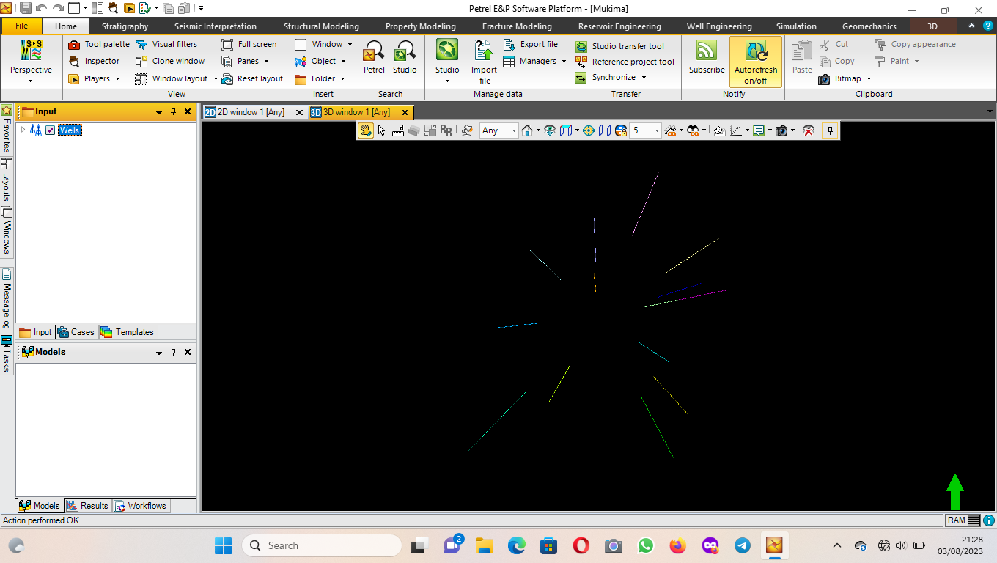

*Figure 3: Picture of 2D of wells in petrel software.*

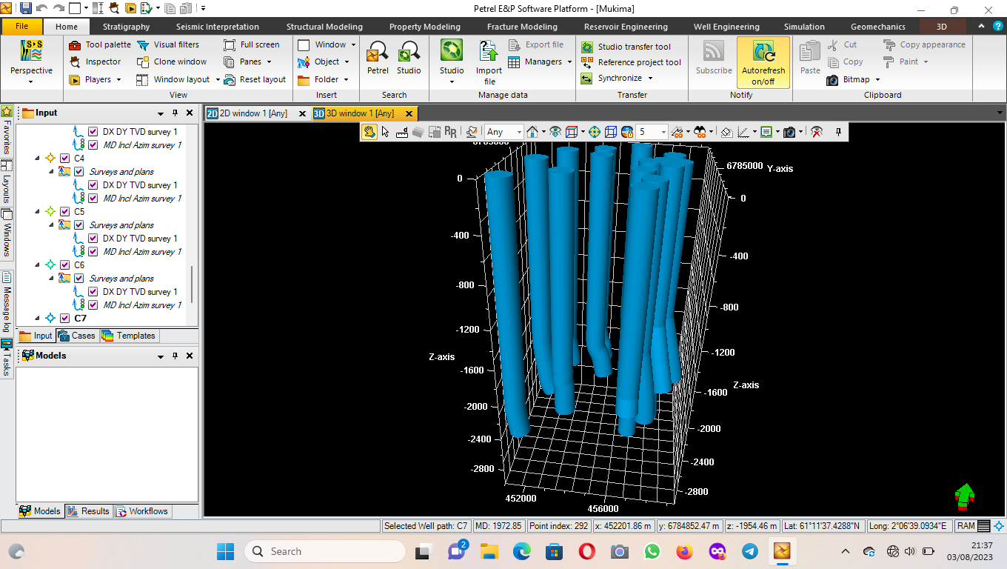

*Figure 4: shows 3D wells in the petrel software with the axis that help us to determine the distance between wells.*

14

Next was to import well logs on selection and file extension was .las file and file of type was well log (las) (*.las)and we viewed that using well selection window were we input well in window and global well logs and the result is shown below.

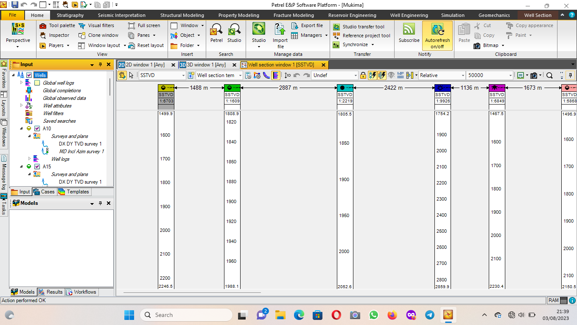

*Figure 5: shows the wells viewed in well selection window.*

At the well logs, we edited the wells by clicking on template settings and we selected the type of log we need to edit, some of the features were color, line type, block type, point size, point color and point symbol among others.

Next was to create another folder and that was well top folder, then import the well tops on selection and go to well top folder and add well top file, the file of type was petrel well tops (ASCII) (*.*). We viewed this in 3D window and the result is shown below.

15

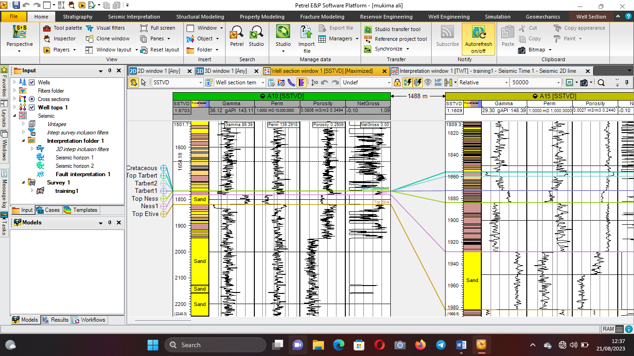

*Figure 6: shows global wells and well tops.*

**Well tops and Global wells**

The last session we had in petrel was about seismic interpretation were we created another folder which was New seismic main folder and we add new seismic survey, we right click on survey one and we import on selection were we used training1.sgy file and seg y seismic data(*.*) as files of type. We viewed that interpretation window and the result is shown below. Before. On a toolbar, we went to seismic interpretation and we inserted both faults and horizons were we also clicked on both faults and horizons for more editing, some of the features were color, line size, point color and point symbol or size even the name among others and final result is shown below

16

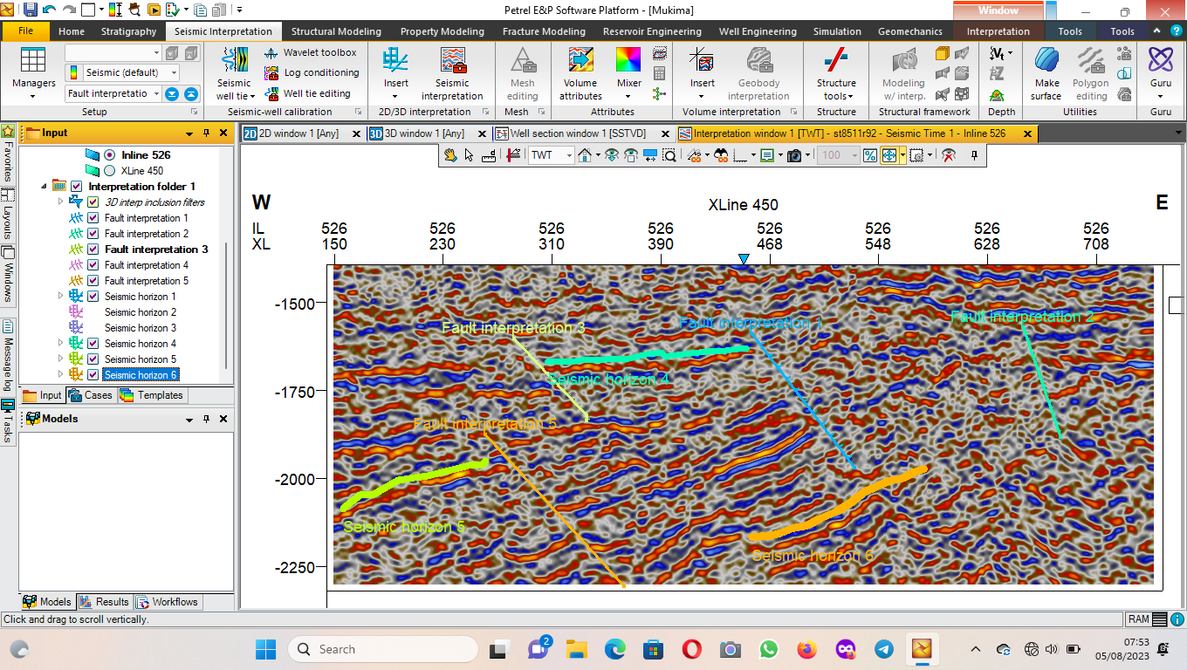

*Figure 7: shows the interpreted seismic data with named faults and horizons viewed in interpretation window.*

We all gained that because of Allah, Mr Mushumba Mark and Mr Musisi Norbert who were the people who took us through those and by now I have prior knowledge about petrel software. Thank you Tarn energy limited.

**2.2.2 ArcGIS**   
ArcGIS is a geographic information system (GIS) software suite developed and maintained by Esri. It was first released in 1999 and originally was released as ARC/INFO, a command line based GIS system for manipulating data. ARC/INFO was later merged into ArcGIS Desktop, which was eventually superseded by ArcGIS Pro in 2015. ArcGIS Pro works in 2D and 3D for cartography and visualization, and includes machine learning (ML).

Esri also provides server side ArcGIS software for web maps, known as ArcGIS Server.

Here is a brief history of ArcGIS software:

1969: Jack Dangermond founds Environmental Systems Research Institute (ESRI) in Redlands, California.

17

1981: ESRI releases ARC/INFO, the first commercial GIS software.

1999: ESRI releases ArcGIS, a new GIS software suite that combines the functionality of ARC/INFO

with a graphical user interface.

2004: ESRI releases ArcGIS Desktop, a new version of ArcGIS that includes a number of new features

and capabilities.

2015: ESRI releases ArcGIS Pro, a new version of ArcGIS that is designed for 2D and 3D mapping and

visualization.

2023: ESRI releases ArcGIS 10.9, the latest version of ArcGIS.

ArcGIS is a powerful and versatile software suite that can be used for a variety of tasks, including:

Mapping: ArcGIS can be used to create maps of any scale, from local to global.

Data analysis: ArcGIS can be used to analyze spatial data to answer a variety of questions.

3D modeling: ArcGIS can be used to create 3D models of the earth and its features.

Web mapping: ArcGIS can be used to create web maps that can be shared with others.

GIS development: ArcGIS can be used to develop custom GIS applications.

ArcGIS is a widely used software suite by businesses, governments, and academia. It is a valuable tool

for anyone who needs to work with spatial data.

**Arc map**

We installed the ArcGIS software from setup and after we opened it and its interface was like as shown

below

18

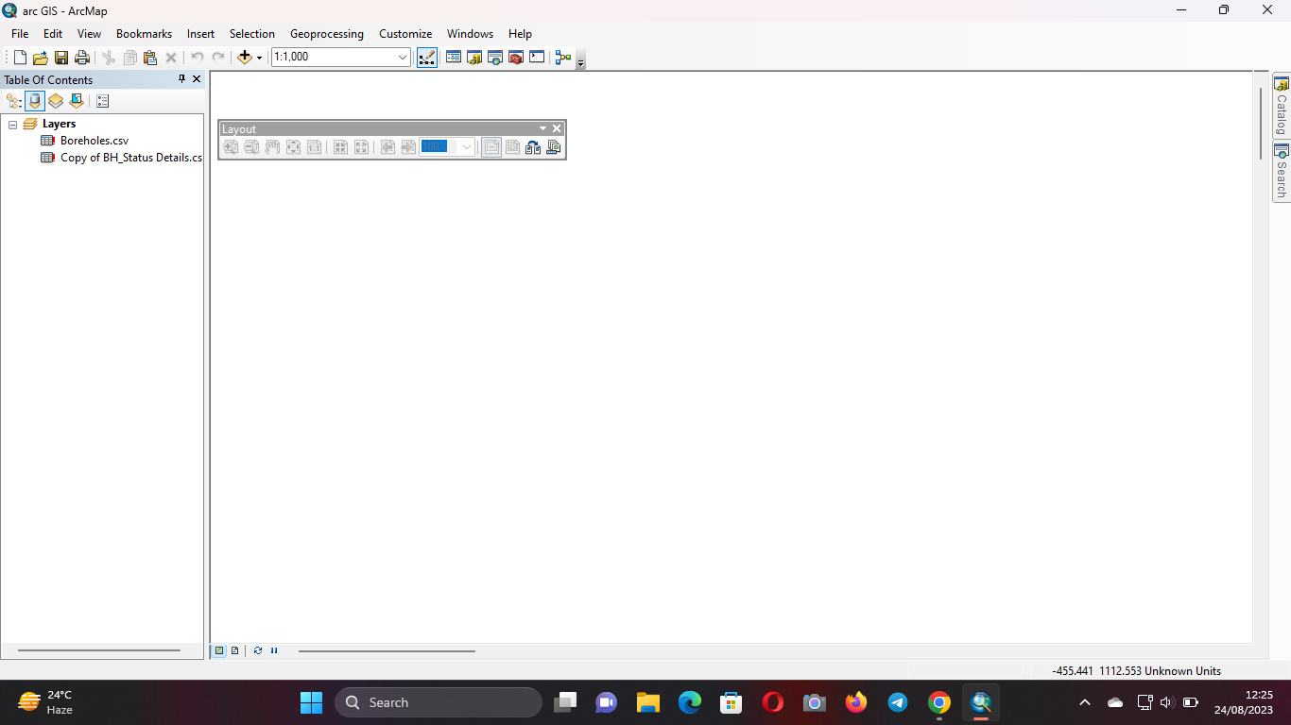

*Figure 8: shows the ArcGIS interface.*

After then we got shape files some from internet and others we shared directly using flash disk and we shared them to our colleagues. The interface was showing file, edit, view, bookmarks, insert, selection, geoprocessing, customize, windows and help on the upper toolbar. On windows option is where you press and see the catalog and table of contents which we used mostly. Under catalog we connected to the folder and we added data from our shape files which we placed them on the desktop and we added Data. Or we added data from the toolbar below the selection and we added data from the desktop. The data were added in the folder form.

Next was to Open the catalog and we opened the folder we added which contained our data and we added Uganda district shape files 2019 were also seen in the table of contents below the layers. The method of adding shape files were to drug them into the interface and the interface formed is shown below.

19

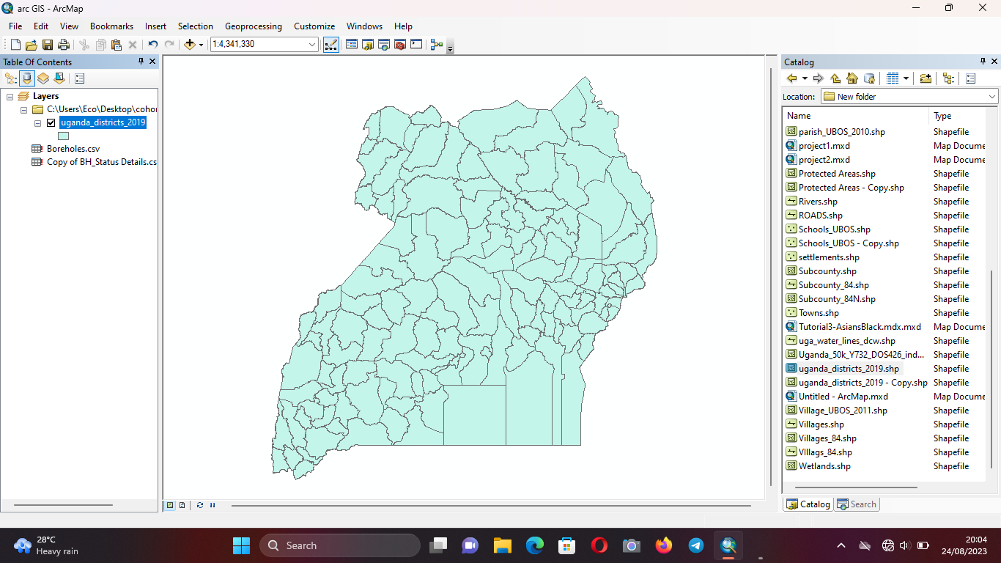

*Figure 9: shows the map of Uganda in arc map.*

To label the district we right clicked on the Uganda districts in the table of contents and we clicked label

feature and the features we also labeled.

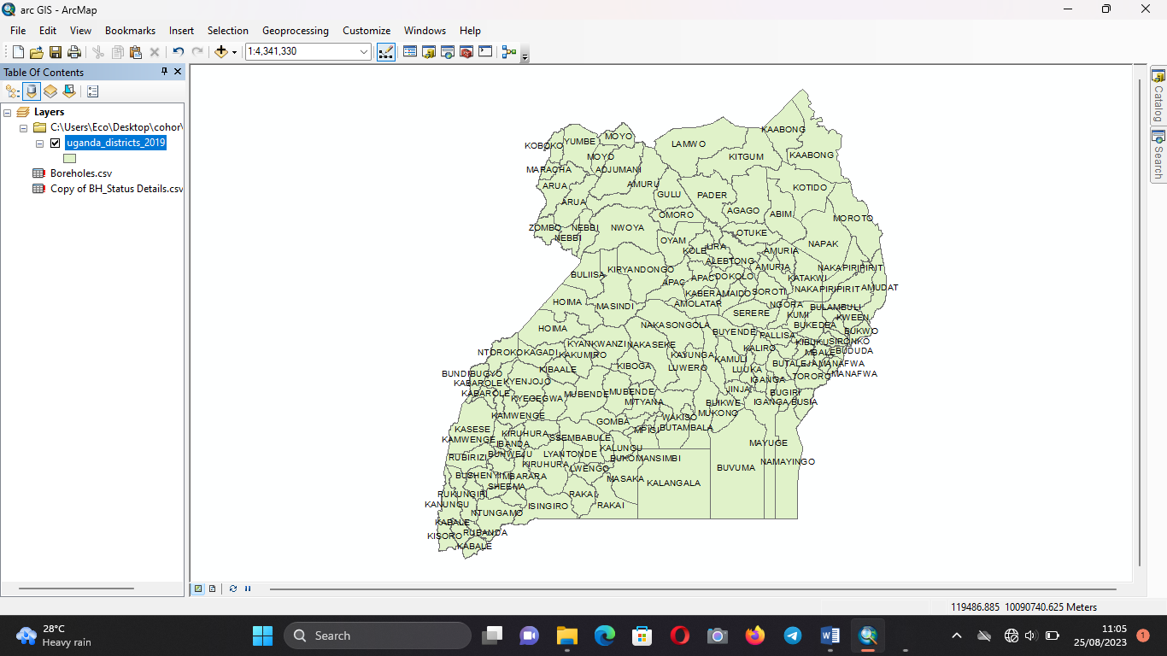

*Figure 10: shows the named districts in Uganda.*

20

A labeled map of Uganda

Next was to select three nearby districts in Uganda were we right on Uganda districts 2019 in table of contents and we moved to properties, on toolbar of properties we selected definition query were we also moved to query builder and we searched DName2019and we selected it, next was to click on in button and we opened the brackets were we add our districts. This was done by selecting get unique values and go to and we wrote the Ssembabule, masaka and Mpiji districts and then we clicked ok for all. We got some error because to choose three districts, they must be near to each other and we added only

|  |  |  |  |
| --- | --- | --- | --- |
| Ssembabule | District | as | shown |

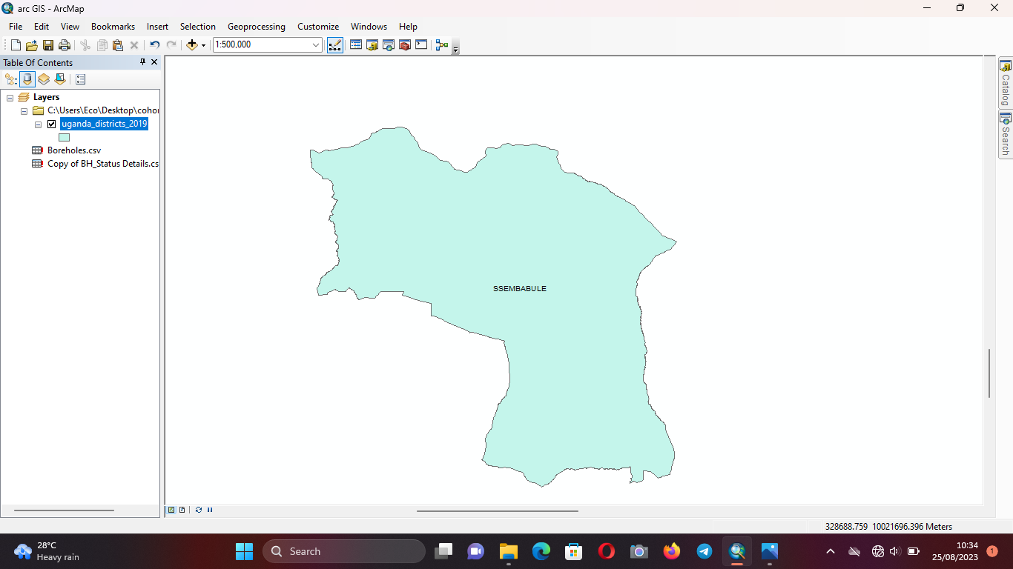

*Figure 11: shows a clipped map of Ssembabule district from Uganda.*

21

From there we were able to drag and add some features like villages and we named them, sub counties, wetlands among others

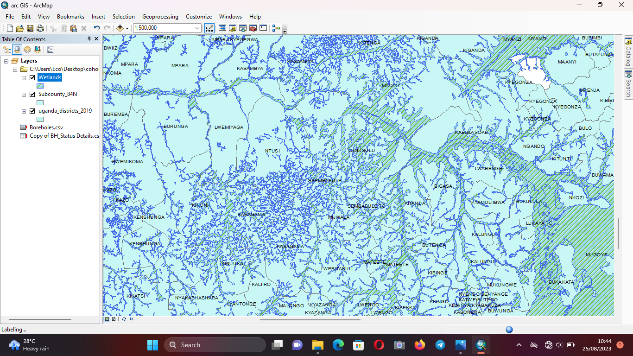

*Figure 12: shows the map with labeled features in ArcGIS software.*

**Google Earth**   
From there, we downloaded google earth and we searched for our villages and me I looked for Kyambogo University CTF as also shown below.

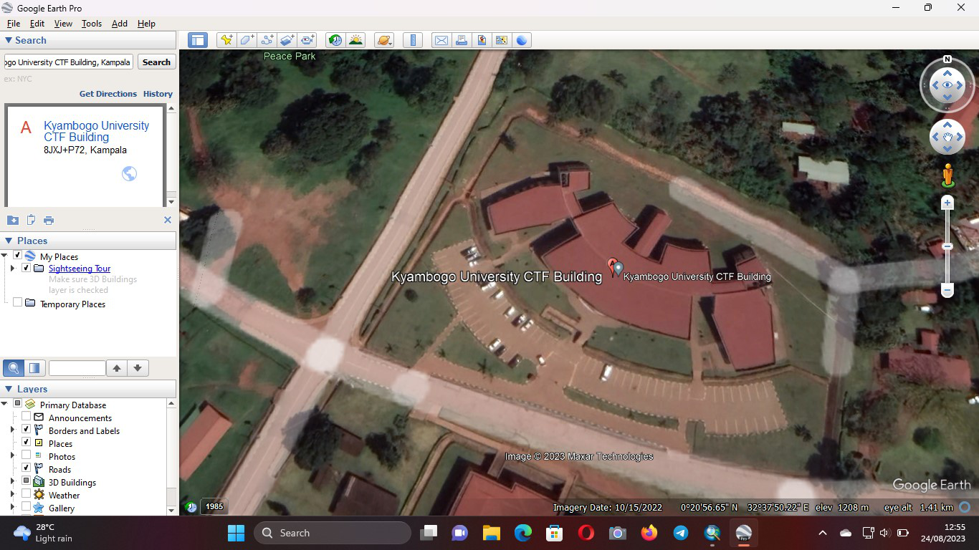

*Figure 13: shows the CTF grounds of Kyambogo University obtained from using google earth.*  22

**2.3.0 WORKPLACE SKILLS**   
At first we learnt workplace skill concepts and essentials where we differentiate between skills and talent even we identified different workplaces like virtual and physical workplace. The virtual workplaces were the online like Jiji and Amazon among others while physical workplaces are like officers, markets among others.

We were confused with bodaboda guys with their workplaces and we discussed that for long time. The confusion was between road and stage and we confirmed stage as their workplaces. Then next was to learn the behavior at the workplace, this was given to a reason of finding frustrated and nasty people in the workplace, this can be your boss or your workmate who can annoy.

We learnt the techniques to overcome such a challenge such as keeping quiet on a useless note. You can also have a bias to the boss or vise vasa where you need to get patience for that sinario.

**2.3.1 CV and resumes**   
Then we also learnt on CV and resumes how they differ and how to write them

Table show the different between CV and resumes

We got an example of a professional and a graduate trainee CVs and resumes and we discovered that the reasons why we lose jobs is due to our interest during application, we do not expose our interest and we just write. Imagine you find and email without a subject and is not composed, the trainee just sends his or her documents to the company HR. For the professionalisms, their CVS are good and they write a good resumes where they show interest to HR in the jobs they apply for.

**2.3.2 Bidding**   
Bidding was also part of our work to learn it during the workplace skills session where we learnt how to win a bid as a company manager and how to look for bid in newspapers in either daily monitor or new vision and even observer, we also learnt on how to apply for a bid as a managing director. We got an example from madam Mwesigwa Diana Nakiwala about on how they Lost a bid after being the second winner as Tarn energy services limited and it was due to lack of funds and slb worn that bid that was advertised by PAU.

23

**2.3.3 Research tools**   
Also under workplace skills, we learnt to use research questioner tools like Kobo toolbox and google forms were we organized our research example and we shared the forms within ourselves. We compared to and both we good but Kobo toolbox was extra because one can fill it without data bundles while Google forms you need to have data to fill them.

All the above knowledge and skills we got it because of Allah, Ms Mwesigwa Diana Nakiwala, Ms Isabella, Mr Billy and Mr Javiira. Those people where compitant in helping and they were ready for us to learn more from them. Thank you Tarn Team.

**2.4.0 HSE**   
In HSE session, at first we were reminding the heilacy in controlling hazards and the good step was to eliminate, substitute, engineer control, administrative control and the last priority was to wear personal protective equipment. After then we discussed the oil and gas industry background in Uganda sector and the status of oil and gas in Uganda. Then we talked about the jobs like Drilling engineer, Mud logger, Project manager and Reservoir engineer. How risky they are according to health and safety, the one for drilling and mud logging were the very risky jobs on oil rig and HSE engineer was the very good job in that sector but requires some attention and time even decision has to be careful. The outcomes for drilling engineer we discussed were dermatitis, fatigue and have ergonomic hazards due to standing postures and repetitive movements.

**2.4.1 Hazard identification and risk analysis**   
Hazard identification and risk analysis was also done on the next day were we walked around the compound for Tarn Energy Services Limited to identify the hazards and some hazards we identified were unsafe roofing tiles that can fall down and find a stakeholder to harm him or her, unsafe electrical outlet sockets and bush around that can accommodate Snakes. We sat and we started to analyze the identified hazards and put a mitigation measures like the tiles were removed from up and bush was cleared and even the exposed sockets were covered.

A term used to describe the overall process or method where you:

✓Identify hazards and risk factors that have the potential to cause harm (hazard identification).

24

✓Analyze and evaluate the risk associated with that hazard (risk analysis, and risk evaluation).

✓Determine appropriate ways to eliminate the hazard, or control the risk when the hazard cannot be

eliminated (risk control).What if I am new to the workplace?

To learn about the hazards of your job, you can:

✓Ask your supervisor

✓Ask a member of the health and safety committee.

✓Ask about SOPs and precautions for your job

✓Check product labels and SDS

✓Ask about operating instructions.

✓Ask about safe work procedures, processes, etc.

✓Pay attention to signs and other warnings.

Those are some of the techniques we got during hazard identification and risk analysis and even we got

the steps followed while caring out risk assessment and they were to identify the hazards, determine the

exposure of that identified hazard, asses the likelihood and severity of risk or hazard, take action to

eliminate or control the hazards and risks and then evaluate the process.

Accident and incident investigation were the next task were we learnt the objectives, why we investigate,

who do investigation and what are the some of the techniques to carry out investigation. We had also the

investigation drill forms and we filled them as the work of supervisors.

An accident and incident investigation is a systematic process of gathering and analyzing information

about an event that has caused harm to people, property, or the environment. The goal of an investigation

25

is to identify the root causes of the incident so that corrective actions can be taken to prevent it from happening again.

The specific steps involved in an accident and incident investigation will vary depending on the circumstances of the incident. However, the following are some general steps that are typically followed:

1. Secure the scene: The first step is to secure the scene of the incident to prevent further harm. This may involve cordoning off the area, removing any hazards, and preventing unauthorized personnel from entering the scene.

2. Identify and interview witnesses: The next step is to identify and interview witnesses to the incident. This can help to gather information about what happened, who was involved, and what the circumstances were.

3. Collect physical evidence: The investigation team will also collect physical evidence from the scene of the incident. This can include photographs, measurements, and samples of any materials or objects that were involved in the incident.

4. Analyze the data: The investigation team will then analyze the data that they have collected. This may involve looking at factors such as human error, equipment failure, and environmental conditions.

5. Identify the root causes: The most important step in the investigation is to identify the root causes of the incident. This is essential to understanding why the incident happened in order to prevent it from happening again.

6. Make recommendations for corrective actions: Once the root causes of the incident have been identified, the investigation team will make recommendations for corrective actions. These actions may involve changes to procedures, equipment, or training.

The goal of an accident and incident investigation is to prevent similar incidents from happening in the future. By identifying the root causes of an incident and implementing corrective actions, organizations can improve their safety culture and reduce the risk of accidents and incidents.

**Techniques**

26

Start the investigation as soon as possible. The sooner you start, the easier it will be to gather evidence and interview witnesses.

Be objective and impartial. The goal of the investigation is to find the facts, not to assign blame.

Interview all relevant witnesses, including the injured person, if possible.

Collect as much physical evidence as possible. This could include photographs, measurements, and samples of any materials or objects that were involved in the incident.

Analyze the data carefully and identify the root causes of the incident.

Make recommendations for corrective actions that will prevent similar incidents from happening in the future.

**2.4.2 Personal protective equipment**   
We learnt about personal protective equipment like groves, helmets, fall arrestors, googles and so others, their expiry date, the different types of elements and how to check their originally and even the safety boots. Here are some personal protective equipment we looked deep into them;

**Helmets**

Hard hats: Hard hats are the most common type of helmet used in the oil and gas industry. They are designed to protect the head from impact and falling objects. Hard hats must meet the ANSI Z89.1-2018 standard to be considered safe for use in the oil and gas industry.

Bump caps: Bump caps are a type of helmet that provides less protection than a hard hat. They are often worn by workers who are not at risk of high impact or falling objects. Bump caps do not meet the ANSI Z89.1-2018 standard and are not considered to be as safe as hard hats.

Lantern helmets: Lantern helmets are hard hats with a built-in light. They are used by workers who need to work in dark or poorly lit areas. Lantern helmets must meet the ANSI Z89.1-2018 standard to be considered safe for use in the oil and gas industry.

27

Fire resistant helmets: Fire resistant helmets are designed to protect the head from heat and flames. They are worn by firefighters and other workers who are at risk of fire exposure. Fire resistant helmets must meet the NFPA 1971-2022 standard to be considered safe for use in the oil and gas industry.

Electrical hazard helmets: Electrical hazard helmets are designed to protect the head from electrical shock. They are worn by workers who work with electrical equipment. Electrical hazard helmets must meet the ANSI/ISEA 103-2021 standard to be considered safe for use in the oil and gas industry.

Acid gas helmets: Acid gas helmets are designed to protect the head from harmful gases, such as hydrogen sulfide. They are worn by workers who work in areas where there is a risk of exposure to these gases. Acid gas helmets must meet the NIOSH 42 CFR 84 standard to be considered safe for use in the oil and gas industry.

**Safety boots**

Steel toe boots: Steel toe boots are designed to protect the feet from impact, such as from falling objects. They are required by law in many oil and gas operations.

Composite toe boots: Composite toe boots are similar to steel toe boots, but they are made of a composite material, such as carbon fiber or fiberglass. Composite toe boots are lighter than steel toe boots and are often preferred by workers who need to be agile.

Waterproof boots: Waterproof boots are designed to keep the feet dry in wet or humid conditions. They are important for workers who are working in areas where there is a risk of water exposure, such as near pipelines or in floodwaters.

Oil and chemical resistant boots: Oil and chemical resistant boots are designed to protect the feet from exposure to oil, chemicals, and other hazardous materials. They are important for workers who are working in areas where there is a risk of exposure to these materials, such as in refineries or chemical plants.

Slip-resistant boots: Slip-resistant boots are designed to prevent slipping on wet or oily surfaces. They are important for workers who are working in areas where there is a risk of slipping, such as on loading docks or in production areas.

28

Insulated boots: Insulated boots are designed to keep the feet warm in cold weather. They are important for workers who are working in cold environments, such as in arctic regions or during winter months.

**Arrestors**

Fall arrestors are a type of personal protective equipment (PPE) that is designed to stop a worker from falling from a height. They are required by law in many oil and gas operations.

There are two main types of fall arrestors: self-retracting lanyards (SRLs) and static lanyards. SRLs are the most common type of fall arrestor used in the oil and gas industry.

Fall arrestors must be used in conjunction with a body harness. The body harness is worn by the worker and it is attached to the fall arrestor. The fall arrestor should be inspected regularly for damage and should be replaced if it is damaged.

In addition to fall arrestors, there are other fall protection measures that can be used in the oil and gas industry, such as guardrails, safety nets, work platforms, and personal fall arrest systems (PFAS).

The specific fall protection measures that are required will vary depending on the specific hazards that the worker is exposed to. It is important to consult with the employer or safety professional to determine the appropriate fall protection measures for the job.

**2.4.3 Emergency response**   
We learnt also about emergency response and we got a training on how to respond to Aram on either condition. 2e first failed the response because Mr Billy started the Aram and we thought it was just an ambulance horn passing through Ntinda hence he came and tell us on how to respond to the Aram. We went to fire assembly point and Mr Lenat Owora started to call one on one by our names to see where we are present and we found out that of 20 trainees only 3 were absent. We got another training about emergency response by Mr Musimenta Isaac and at that training we even recorded the activity on fire drill form and the form is also attached to the report on the appendix. We recorded the time taken to reach the point and many others. We also got more knowledge about emergency response as shown on the next paragraph.

29

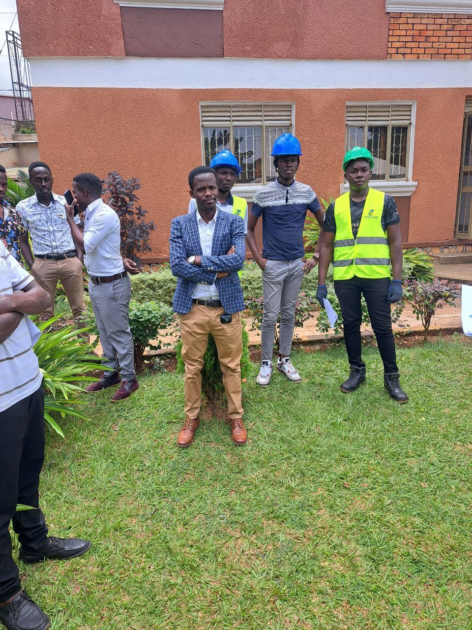

*Figure 14: shows the assemble on the fire point after fire arm was started.*

30

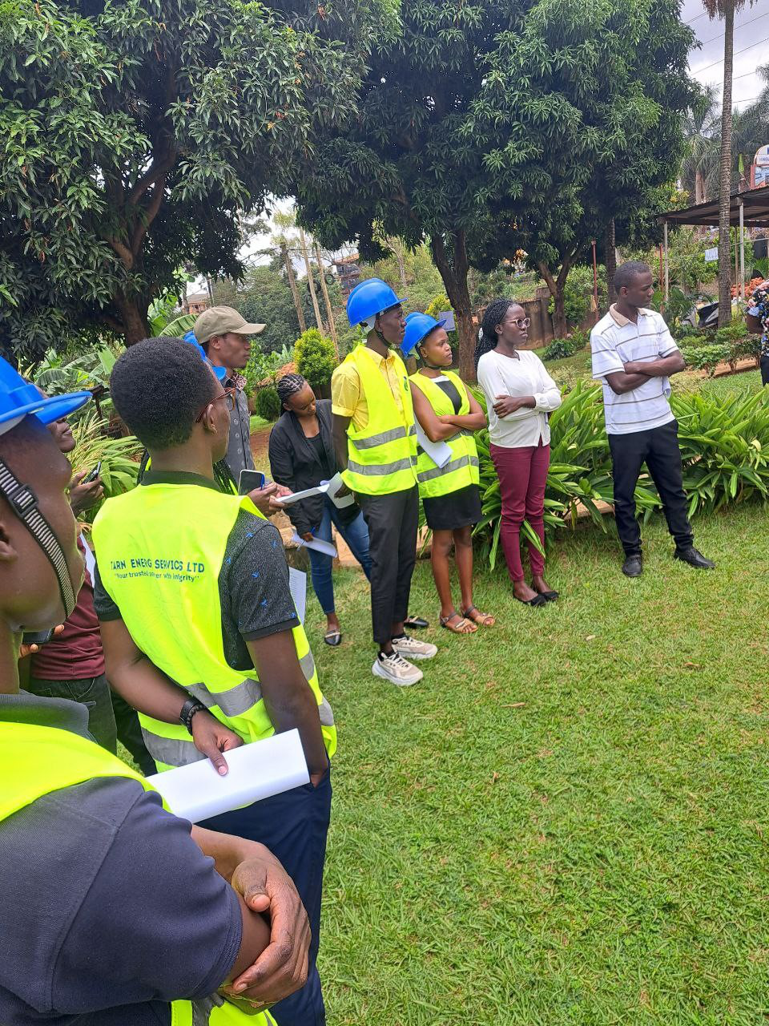

*Figure 15: shows emergence response.*

31

Emergency response and evacuation are the two main components of emergency management. Emergency response is the immediate action taken to address an emergency, while evacuation is the process of moving people to a safe location. The specific steps involved in emergency response and evacuation will vary depending on the type of emergency, but some general principles apply to all situations.

The first step is to provide early warning to people in the area of the emergency. This can be done through a variety of methods, such as sirens, public address systems, or text messages. Once people have been warned, they may need to be evacuated from the area of the emergency. This should be done in an orderly and efficient manner, following a pre-planned evacuation route. Once people have been evacuated, they will need to be triaged to determine the severity of their injuries. Those with the most serious injuries will be treated first.

After the emergency has passed, the focus will shift to recovery. This includes repairing damage, restoring services, and helping people to get back to their normal lives.

Tips for emergency response and evacuation:

Have a plan and practice it regularly.

Know the evacuation routes and exits in your building.

Stay calm and follow the instructions of emergency personnel.

Help others if you can.

**2.4.4 Fire safety**   
Next session in HSE we learnt about fire safety were we looked into classes and types of fire, different fire extinguishers and how to use them, fire triangle like fuel, heat and oxygen and when you remove one fire can't start, and others we looked into them during emergency response. On using fire extinguisher, we use power extinguisher were we use the formula of PASS.

Follow PASS

32

✓Pull pin on extinguisher.

✓Aim at base of flames

✓Squeeze the trigger holding extinguisher upright

✓Sweep from side to side at base of fire until extinguished.

Fire extinguisher image

We also filled the form for the refilling of the fire extinguisher and we understood the concept of the powder extinguisher. Me I didn't know that the power in the cylinder has expire date and I came to know where they write the important details of the extinguisher.

Here are the different types of fire and their corresponding extinguishers:

Class A fires are fires involving ordinary combustible materials such as wood, paper, and textiles. They are extinguished by cooling the fuel to below its ignition temperature. Water is the most common extinguishing agent for Class A fires.

Class B fires are fires involving flammable liquids and gases such as gasoline, oil, and grease. They are extinguished by smothering the fuel or by reducing its oxygen content. Foam, dry powder, and carbon dioxide are common extinguishing agents for Class B fires.

Class C fires are fires involving energized electrical equipment. They are extinguished by using an extinguishing agent that does not conduct electricity. Carbon dioxide and dry powder are common extinguishing agents for Class C fires.

Class D fires are fires involving combustible metals such as magnesium, sodium, and potassium. They are extinguished by using an extinguishing agent that reacts with the metal to form a fire-resistant layer. Dry powder is the only extinguishing agent that is effective for Class D fires.

33

Class K fires are fires involving cooking oils and fats. They are extinguished by using an extinguishing agent that cools the oil or fat to below its ignition temperature. Wet chemical is the only extinguishing agent that is effective for Class K fires.

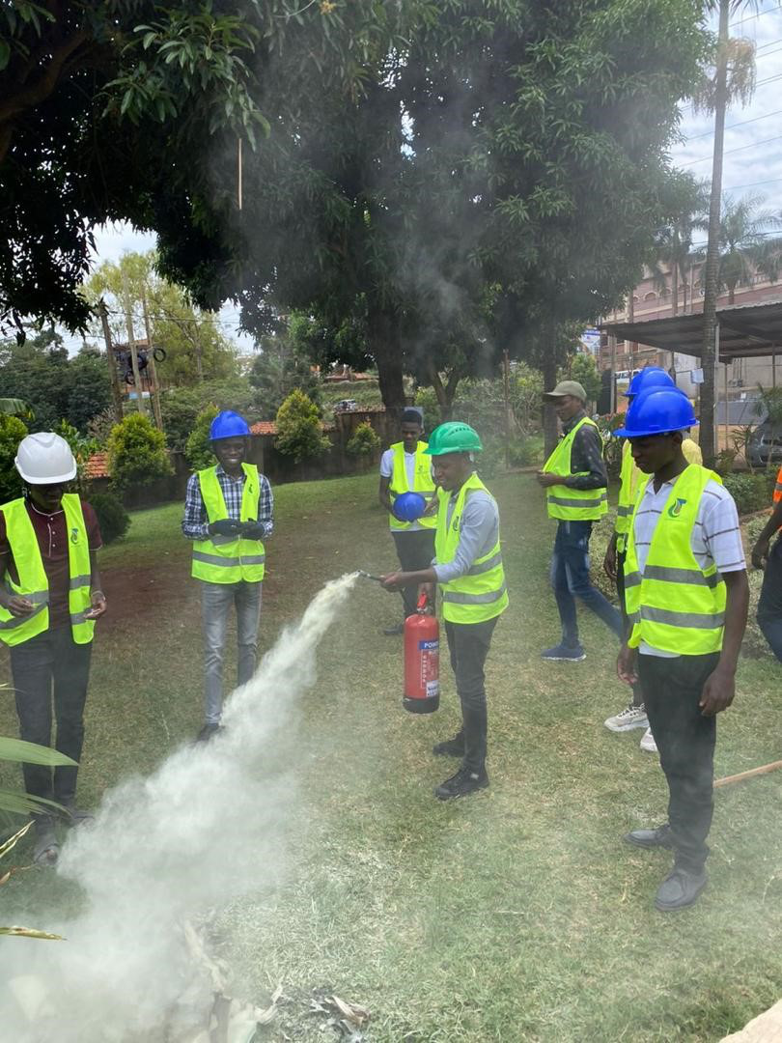

*Figure 16: shows the way we did while extinguishing fire.*

34

**First aid**

We also carried out experiment on first aid and I were the victim, the experiment was to do first aid to a person with a deep cut as the steps in the paragraph. To give first aid to a person with a small cut, wash your hands with soap and water, then gently clean the cut with soap and water. Be careful not to scrub the cut. Apply a bandage to the cut, making sure it is clean and dry. Elevate the cut to reduce swelling. Monitor the cut for signs of infection, such as redness, swelling, or pus. If you see any of these signs, seek medical attention.

**Tips:**

If the cut is bleeding heavily, apply pressure to it with a clean cloth or bandage.

If the cut is on a joint, such as the finger or toe, splint it to prevent further injury.

If the cut is on the face, be careful not to apply too much pressure, as this can cause bruising.

If the cut is deep or jagged, see a doctor.

Do not use alcohol or hydrogen peroxide to clean the cut, use a butterfly bandage on a small cut, or remove dirt or debris from the cut with tweezers.

35

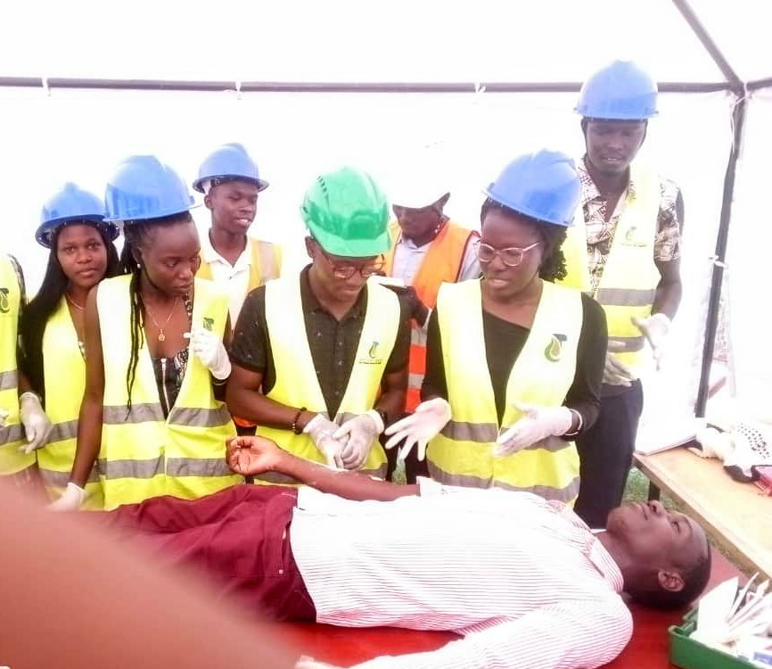

*Figure 17: shows first aid experiment.*

**2.4.5 12 golden rules in HSE**   
Then the last session was about 12 golden rules in HSE that was set by total energies and power and we watched the video showing different people telling us about the 12 golden rules and rules was stated by one person and they are the following;

To prevent occupational accidents, Total Energies employees should avoid high-risk situations, check the condition of their equipment before use, use tools and equipment in line with the manufacturer's specifications, position their bodies to minimize excessive strain, handle tools safely, check that their personal protective equipment (PPE) is in good condition before use, wear a helmet with the chin strap fastened, wear the PPE adapted for the task and the area in which they are working, wear a life jacket whenever required, check the condition of their vehicle before use, always wear a seatbelt, and do not exceed the speed limit and adapt their driving to road conditions.

In addition to these rules, Total Energies employees should also report any unsafe conditions or practices, take action to stop work if the risk is not being properly managed, and create a culture of safety where

36

everyone feels comfortable speaking up about safety concerns. By following these rules and commitments, Total Energies employees can help to create a safe workplace for themselves and their colleagues.

Those rules were set by total energies and power for their employees but they can also be used in other sectors. Let me take this opportunity to thank those people who took us through that session and we gained a lot more than those. Many things we learnt about HSE and they were practical more so about the personal protective equipment which they look more wearied that everyone knows them but we were supplied by the expiry date and the expiry date is also indicated there. Thank you Mr Musimenta Isaac, Mr Lenat Owora among others who took us through this session.

**2.5.0 PROJECT MANAGEMENT**   
We also went through the project management session we learnt about brief overview of project management, organization structure of project management, the role of project management and the project manager, making the project plan and others. Ms Nansamba Patricia and Mr Musisi Norbert were the people who took us through that session of project management and we learnt a lot

Project management is the application of knowledge, skills, tools, and techniques to project activities to meet the project requirements. It is a broad discipline that encompasses the planning, organizing, executing, monitoring, and controlling of projects.

The goal of project management is to deliver the project on time, within budget, and to the required quality. Project managers achieve this goal by working with a team of stakeholders to define the project scope, create a plan, and track progress. They also identify and manage risks, and communicate with stakeholders throughout the project.

Project management is a complex and challenging field, but it is also a rewarding one. Project managers play an essential role in bringing projects to life and delivering value to stakeholders.

**2.5.1 Organization structure of project management.**

The organizational structure of project management is the way in which the people involved in a project are organized. It defines the roles, responsibilities, and reporting relationships of the project team members.

37

There are three main types of organizational structures in project management:

Functional structure: In a functional structure, the team members are organized into functional departments, such as marketing, finance, and engineering. The project manager is responsible for coordinating the work of the different departments, but the team members report to their functional managers. This structure is often used for smaller projects or projects that are not very complex.

Matrix structure: In a matrix structure, the team members are assigned to both a functional department and a project team. The project manager has authority over the project team members, but the functional managers retain some authority over their staff. This structure is often used for larger or more complex projects.

Projectized structure: In a projectized structure, the project team is a separate entity from the rest of the organization. The project manager has full authority over the project team members, and they report directly to the project manager. This structure is often used for projects that are very complex or long-term.

The best organizational structure for a particular project will depend on the size and complexity of the project, the availability of resources, and the culture of the organization.

Here are some of the factors to consider when choosing an organizational structure for a project:

The size and complexity of the project: Larger and more complex projects will require a more formal organizational structure, such as a matrix or projectized structure.

The availability of resources: If the organization does not have enough resources to dedicate to a full-time project team, then a functional structure may be more appropriate.

The culture of the organization: Some organizations are more hierarchical and bureaucratic, while others are more flexible and adaptable. The organizational structure should be chosen to fit the culture of the organization.

38

The organizational structure of project management is an important factor in the success of a project. By choosing the right structure for the particular project, the project manager can help to ensure that the project is completed on time, within budget, and to the required quality standards.

**2.5.2 The role of project manager**   
A project manager is responsible for overseeing the planning, execution, and completion of a project. They are responsible for ensuring that the project meets its goals and objectives, and that it is delivered on time, within budget, and to the satisfaction of all stakeholders.

The specific roles and responsibilities of a project manager can vary depending on the size and complexity of the project, but some common responsibilities include defining the project scope, creating a project plan, managing the project team, communicating with stakeholders, monitoring and controlling the project, and closing the project.

In addition to these core responsibilities, project managers may also be responsible for tasks such as managing risks, managing change, procurement, and quality assurance.

Project managers must have a variety of skills and knowledge in order to be successful in their role, including communication, problem-solving, leadership, organizational skills, time management, risk management, and change management.

Project managers play a vital role in the success of any project. By having the right skills and knowledge, they can help to ensure that projects are delivered on time, within budget, and to the satisfaction of all stakeholders.

We also presented the stages of project management were the presentation was organized by some of our colleagues. This was due to the last assignment madam had given to us about how can you organize yourself as a project manager to finish the given task and the first presenter was Eng. Emma who presented the project initiation, next was me who presented project planning, next was Kibuuka Daniel who presented execution of the project, next was Madam Sheila who presented project monitoring and Wolimbwa Kenneth presented project closer.

39

**2.5.3 PROJECT PLANING**   
Here are the steps involved in planning and executing the construction of an oil and gas processing plant:

Project Initiation

1. Define the project objectives. What is the purpose of the oil and gas processing plant? What are the specific goals to be achieved?

2. Identify the stakeholders. Determine the key stakeholders involved, such as investors, regulatory bodies, local communities, and environmental groups.

3. Define the success criteria. What are the key performance indicators (KPIs) that will measure the success of the project, such as completion time, budget adherence, safety standards, and environmental compliance?

Project Planning

4. Develop a project scope statement. Clearly define the scope of work, including the specific facilities, infrastructure, and equipment to be constructed.

5. Create a work breakdown structure (WBS). Break down the project deliverables into smaller tasks, such as site preparation, construction of storage tanks, installation of processing units, and pipeline connections.

6. Develop a project schedule. Create a timeline with start and end dates for each task in the WBS, taking into account dependencies and critical paths.

7. Identify required resources. Determine the equipment, materials, and human resources needed for each task and develop a resource allocation plan.

8. Define risks. Identify potential risks that may impact the project, such as cost overruns, delays, safety hazards, or environmental incidents. Develop mitigation strategies for each identified risk.

Project Execution

40

9. Procurement and contracting. Initiate the procurement process, including identifying suppliers, issuing

requests for proposals (RFPs), evaluating bids, and selecting contractors.

10. Construction activities. Oversee the construction activities, ensuring adherence to the project plan,

quality standards, safety protocols, and environmental regulations.

11. Stakeholder management. Regularly communicate with stakeholders to provide project updates,

address concerns, and maintain positive relationships.

12. Quality assurance. Implement quality control measures to ensure that the constructed facilities meet

the required standards and specifications.

Project Monitoring and Control

13. Progress tracking. Monitor the progress of each task against the project schedule and adjust resources

or schedules as needed.

14. Cost management. Monitor project expenditures and compare them to the allocated budget.

Implement strategies to control costs and prevent cost overruns.

15. Risk management. Continuously assess risks, update the risk register, and implement mitigation

actions to minimize their impact.

16. Change management. Document and assess change requests, evaluate their impact on the project, and

seek necessary approvals before implementing changes.

**Project Closure**

17. Commissioning and handover. Oversee the commissioning activities, ensuring that the oil and gas

processing plant is fully operational. Coordinate the handover of the project to the operations team.

18. Performance evaluation. Assess the project's performance against the defined success criteria.

Evaluate if the project objectives have been met and document any lessons learned.

41

19. Project documentation. Assemble all project documentation, including reports, plans, contracts, and warranties, for future reference.

20. Celebrate success. Acknowledge the successful completion of the project and recognize the contributions of the project team.

The deliverables of this project include:

Work Breakdown Structure (WBS): A hierarchical breakdown of tasks required to construct the oil and gas processing plant.

Project Closure Report: A summary of the project's performance, lessons learned, and recommendations for future projects.

Then about project planning, we also used spreadsheet software to plan for the project that was given the period of six months and Mr Musisi Norbert was the one who took us through that session. The question was to do the project for TMT mining company on exploration and development and the manager was assumed to be a worker for Tarn energy services limited. We generated the reference number as TMT - TAR - 2023 - 01 where TMT is the operator, Tar is the contactor as Tarn Energy Services and 2023 is the Year of the project and 01 is the project number as project one. The plan is as below.

42

**2.5.4 Project planning.**

**QN**: You are working for Tarn Energy Services. TMT mining company wants to give work to explore and develop a mine field for lime stone. You are required to plan on how that assistant has to be taken in 6 weeks.

|  |  |  |  |  |  |  |  |  |  |  |  |  |  |  |  |  |
| --- | --- | --- | --- | --- | --- | --- | --- | --- | --- | --- | --- | --- | --- | --- | --- | --- |
| **TMT - TAR - 2023 - 01** | | | | | | | | | | | | | | | | |
| **WEEKS** | **1** | | | | | | | | | | **2** | | | | | |
| **DAYS** | **1** | **2** | **3** | **4** | | | **5** | | | **6** | **1** | **2** | **3** | **4** | **5** | **6** |
| PLANING |  |  |  |  | | |  | | |  |  |  |  |  |  |  |
| EXPLORATION |  |  |  |  | | |  | | |  |  |  |  |  |  |  |
| Hiring personnel |  |  |  |  | | |  | | |  |  |  |  |  |  |  |
| Purchasing equipment |  |  |  |  | | |  | | |  |  |  |  |  |  |  |
| Mobilizing available tools |  |  |  |  |  |  |  | | |  |  |  |  |  |  |  |
| Buying gravimeter |  |  |  |  | | |  |  |  |  |  |  |  |  |  |  |
| Magnetometer |  |  |  |  | | |  | | |  |  |  |  |  |  |  |
| Importing machines |  |  |  |  | | |  | | |  |  |  |  |  |  |  |
| MAGNETIC, GRAVITY SURVEY |  |  |  |  | | |  | | |  |  |  |  |  |  |  |
| Collecting all tools |  |  |  |  | | |  | | |  |  |  |  |  |  |  |
| Surveying |  |  |  |  | | |  | | |  |  |  |  |  |  |  |
| Analyzing data |  |  |  |  | | |  | | |  |  |  |  |  |  |  |
| Reporting |  |  |  |  | | |  | | |  |  |  |  |  |  |  |
|  |  |  |  |  | | |  | | |  |  |  |  |  |  |  |
| **WEEKS** | **3** | | | | | | | | | | **4** | | | | | |
| **DAYS** | **1** | **2** | **3** | **4** | | | **5** | | | **6** | **1** | **2** | **3** | **4** | **5** | **6** |
| DEVELOPMENT PLANING |  |  |  |  | | |  | | |  |  |  |  |  |  |  |
| Hiring personnel |  |  |  |  | | |  | | |  |  |  |  |  |  |  |
| Making plan |  |  |  |  | | |  | | |  |  |  |  |  |  |  |
| PERCHESING TOOLS |  |  |  |  | | |  | | |  |  |  |  |  |  |  |
| Mobilizing available |  |  |  |  |  |  |  | | |  |  |  |  |  |  |  |
| Buying tools, equipment |  |  |  |  | | |  |  |  |  |  |  |  |  |  |  |
| Exporting |  |  |  |  | | |  | | |  |  |  |  |  |  |  |

43

|  |  |  |  |  |  |  |  |  |  |  |  |  |  |  |  |  |
| --- | --- | --- | --- | --- | --- | --- | --- | --- | --- | --- | --- | --- | --- | --- | --- | --- |
| COLLECTING MATERIALS |  |  |  |  |  |  |  |  |  |  | | |  | | |  |
| Buying materials |  |  |  |  |  |  |  |  |  |  | | |  | | |  |
| Transporting them to place |  |  |  |  |  |  |  |  |  |  | | |  | | |  |
| Hiring casual personnel |  |  |  |  |  |  |  |  |  |  | | |  | | |  |
| Sorting them |  |  |  |  |  |  |  |  |  |  | | |  | | |  |
|  |  |  |  |  |  |  |  |  |  |  | | |  | | |  |
| **WEEKS** | **5** | | | | | | **6** | | | | | | | | | |
| **DAYS** | **1** | **2** | **3** | **4** | **5** | **6** | **1** | **2** | **3** | **4** | | | **5** | | | **6** |
| CONSTRUCTION |  |  |  |  |  |  |  |  |  |  | | |  | | |  |
| Camps |  |  |  |  |  |  |  |  |  |  | | |  | | |  |
| Roads |  |  |  |  |  |  |  |  |  |  | | |  | | |  |
| Mining workers hostels |  |  |  |  |  |  |  |  |  |  | | |  | | |  |
| Construction finishing |  |  |  |  |  |  |  |  |  |  | | |  | | |  |
| DECOMISIONING |  |  |  |  |  |  |  |  |  |  | | |  | | |  |
| Removing camps |  |  |  |  |  |  |  |  |  |  |  |  |  | | |  |
| Collecting equips, tools |  |  |  |  |  |  |  |  |  |  | | |  |  |  |  |
| Report writing |  |  |  |  |  |  |  |  |  |  | | |  | | |  |
| **END** | | | | | | | | | | | | | | | | |

**2.6.0 EVENTS AND FANS**

We also had three events, the launch day were we had introduced each other and know each other, Ms Mwesigwa Diana Nakiwala the internship coordinator also introduced the internship program to us, we also got the speech from alumni who was Mr Billy, the guest speaker was Mr Musisi Norbert, and we had question and answer session about the company, the duration of the training among others, and also made some tour for the company offices and installation among other activities. This took place on 3rd July 2023. On 14th July we also had Tarn Energy exposition day where we got communication from different people who were Mr Musisi Norbert, Mr Francis Kaliisa, Mr Arga Seth, and Mr Kanyike Rogers who told us what they pass through and their small journey up to their current situation now. Mr Kaliisa Francis who studied mechanical engineering at Kyambogo University is now expert in electrical Installation and wiring and he also has the company for supplying electrical equipments, Mr Musisi

44

Norbert who was a teacher by professional and he upgraded to petroleum geophysics and he was given a job because he was expert in ArcGIS software but he changed and shown his interest in exploration and now is the senior reservoir engineer after having some training in oil and gas industry, Mr Seith who started his Bachelor's degree of petroleum engineering in china and started working during his last year at the University, since then he upgraded to Master in china also and is now working with CNOOC, Mr Kanyike Rogers who started his diploma at Uganda Petroleum Institute Kigumba and he started that online certificates and he got training in AutoCAD and his first job was because of that software. They talked a lot of stories but I can't even finish now and we gained a lot from them. The last day was the closing date and it held on 4th August 2023 were we have testimony about we expected and what we gained extra from tarn Energy, we also presented our projects on that day like on how we obtained natural gasoline from plastics to our chief guest. We also got the certificate and the photo captured when we were receiving the certificates is also in the appendix. We got communication from the chief guest who came from EACOP and the lecturer head of department in oil and gas management at Victoria University. Networking was also increased and we also got funs during the internship.

First fun we got took place on the exposition day were we had cup filling and we filled water in the cups until we fulfilled the bottle, this was done in a group of about 10 people and we had two groups, our group was a winner in everything and was called group Kamiro. We also had paper racing and we also danced to find your sit, if your sit is taken, you are done with a game. Next day was the project day on Friday were after finishing up making briquettes and we started playing football and we also had a dancing fun. And on the closing day we cut cake and we enjoyed a lot during the session.

45

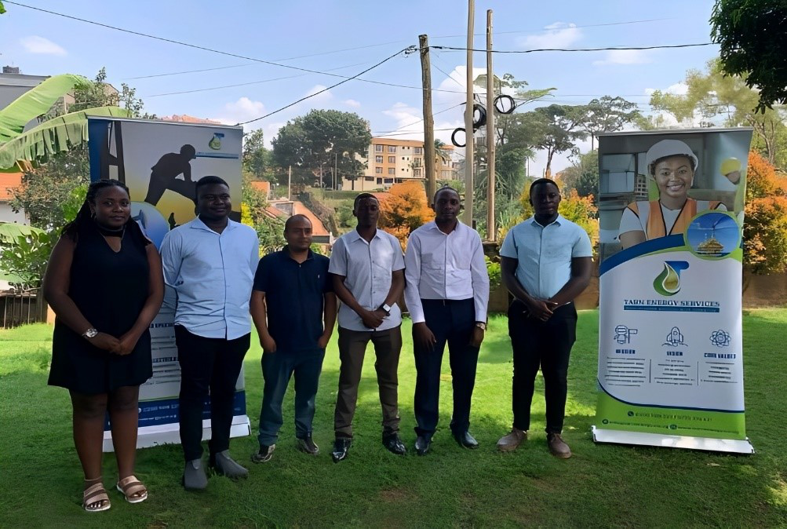

*Figure 18: shows Tarn Energy Executive committee captured during exposition day.*

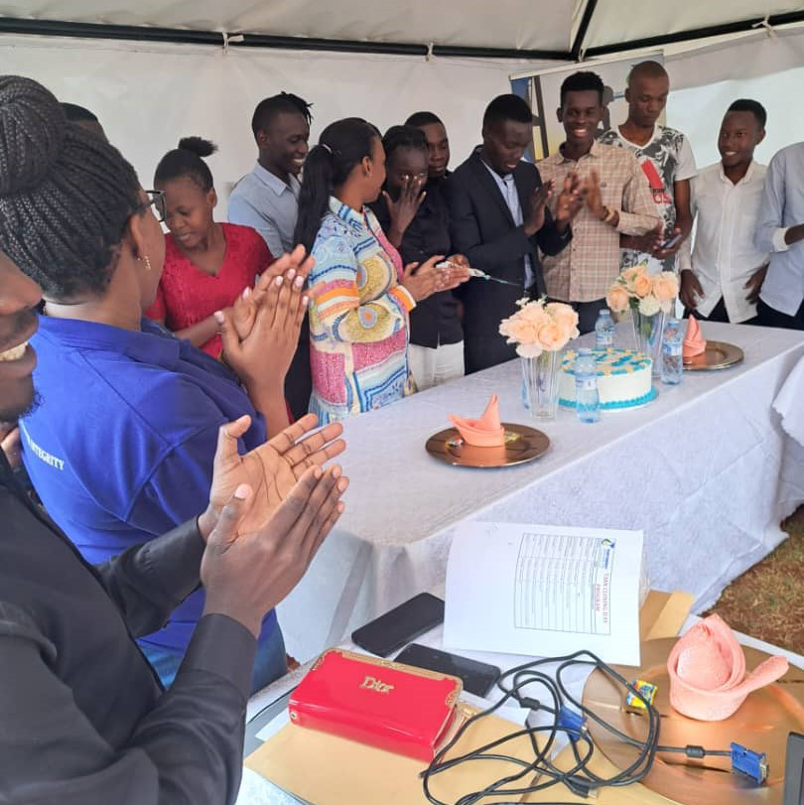

*Figure 19: shows the closing party when we were cutting cake with the chief guest.*

46

**CHAPTER THREE**

**RESULTS AND DISCUSSIONS Pyrolysis**

The results of the study showed that pyrolysis is a promising technology for the disposal of waste materials and the production of renewable energy. The study found that pyrolysis can convert a variety of waste materials, such as biomass, plastics, and tires, into valuable products, such as syngas, bio oil, and bio char.

The study also found that pyrolysis can be a cost-effective way to dispose of waste materials. The study found that the cost of pyrolysis is comparable to the cost of landfilling or incineration.

However, the study also found that there are some challenges that need to be addressed before pyrolysis can be widely adopted. These challenges include the high cost of equipment, the need for further research, and the lack of a clear regulatory framework.

**Workplace skills**

The results of the study showed that there is a skills gap in many industries. The study found that employers are struggling to find qualified workers who have the skills they need to do their jobs effectively.

The study also found that workplace skills are essential for employees to perform their jobs effectively. The study found that employees with strong workplace skills are more productive, more engaged, and less likely to be injured.

The study concluded that there is a need to improve workplace skills training. The study recommended that employers provide more training to their employees and that governments invest in training programs for workers.

**Health safety and environment (HSE)**

47

The results of the study showed that health, safety, and environment (HSE) is a critical issue for businesses. The study found that companies need to implement effective HSE practices to protect their employees, customers, and the environment.

The study also found that there are a number of challenges that businesses face in implementing effective HSE practices. These challenges include the cost of HSE measures, the lack of employee buy-in, and the complexity of HSE regulations.

The study concluded that businesses need to take HSE seriously. The study recommended that businesses develop and implement effective HSE programs and that governments provide support to businesses in implementing these programs.

**Project management**

The results of the study showed that project management is a complex and challenging task. The study found that project managers need to have a variety of skills, such as communication, planning, and problem-solving.

The study also found that project managers need to be able to deal with a variety of challenges, such as scope creep, budget overruns, and schedule delays.

The study concluded that project management is an essential skill for businesses. The study recommended that businesses invest in training their employees in project management.

**Events**

The results of the study showed that events are an important way for businesses to connect with their trainees, customers and stakeholders. The study found that events can be used to raise awareness of a company's products or services, to generate leads, and to build relationships with trainees and customers.

The study also found that event planning can be a daunting task. The study recommended that businesses carefully plan and execute their events.

48

The study concluded that events can be a valuable tool for company business. The study recommended that businesses consider using events as part of their marketing strategy.

**CHAPTER FOUR**

**ACHIEVEMENTS AND CHALLENGES FACED**

**4.0. INTRODUCTION**   
The industrial training session at Tarn Energy Services Limited was a valuable experience that allowed me to gain theoretical and practical knowledge of the energy industry, develop skills in project management, safety, and environmental protection, industrial software and network with professionals in the industry.

One of the most significant achievements was gaining a strong understanding of the energy industry. I learned about the different types of energy, the technologies used to produce and distribute energy, and the environmental impact of energy production. I also learned about the different roles and responsibilities of professionals in the energy industry.

Another major achievement was developing project management skills. I learned how to plan, execute, and monitor projects, and I gained experience in working with teams and managing budgets. I also learned about the importance of safety and environmental protection in project management.

I also learned about safety and environmental protection practices during the session. I learned about the different hazards that can occur in the energy industry and the steps that can be taken to prevent accidents and protect the environment. I also learned about the importance of following safety procedures and regulations.

One of the challenges faced during the session was the amount of information that was covered in a short period of time. The material was sometimes complex and challenging to understand, but I was able to learn a lot by taking notes, asking questions, and participating in discussions.

Another challenge was the strict safety and environmental protection practices that were in place. These practices were sometimes time-consuming, but I understood the importance of following them to protect myself and others.

49

Overall, the industrial training session at Tarn Energy Services Limited was a valuable experience that I am grateful for. I learned a lot about the energy industry and developed skills that will be useful in my future career.

**4.1. ACHIEVEMENTS**   
•Gaining new skills and knowledge: We learnt new skills and knowledge that will be valuable in our future careers. This could include technical skills, soft skills, or industry-specific knowledge.

•Developing professional networks: We developed professional networks by meeting and working with people in our field. This helped us for finding jobs, getting advice, and staying up-to-date on industry trends.

•Getting hands-on experience: We got hands-on experience in our field, which can help us to better understand the work that is involved. This can be helpful for making informed career decisions and for building confidence.

•Providing value to the company: We provided value to the company by completing tasks, helping with projects, and contributing new ideas. This can help the company to save money and to improve its operations.

•Building their resume: Internship can be a great way to build a strong resume and to demonstrate our skills and experience to potential employers. This can make them more competitive in the job market.

**4.2. CHALLENGES FACED**   
•The most and most challenge was about installing software were we tried and some of our computers failed to install the software, me Ssenkima Ashiraf I used the flash disc that was affected by virus and some files were already affected and to share them was also a problem.

•The most challenging part of this week was learning about the different HSE regulations. There are a lot of regulations to follow, and it can be difficult to keep track of them all.

•The software programs were a bit challenging to learn at first.

•During the project of changing PTO, we also got many problems were the cost of materials were high and we suffered during cooling of the condenser were we used a wet cloth and we also lacked equipment.

•We had some trouble understanding the concepts of seismic data interpretation and 3D modeling.

50

•We had to overcome our different learning styles and work styles in order to collaborate effectively on the project management presentation.

•The steep learning curve: we were often thrown into the deep end and expected to learn a lot of new information in a short period of time. This can be overwhelming and stressful, especially if the intern is not familiar with the industry or the company's specific practices.

•The lack of structure: Internships can be unstructured and informal, which can make it difficult for us to know what is expected of them. We may also feel like they are not getting enough guidance or support from our supervisors.

•The feeling of being an outsider: We can feel like they are on the outside looking in, especially if they are the only intern in the department or if they are not given the same opportunities as full-time employees. This can lead to feelings of isolation and frustration.

•The lack of recognition: We often do not receive the same recognition as full-time employees, even if they are doing good work. This can be discouraging and make us feel like their contributions are not valued.

51

**CHAPTER FIVE**

**RECOMMENDATION AND CONCLUSION**

**5.1. RECOMMENDATIONS**

Based on the discussion, we recommend the following:

We recommend that the company provide more training on HSE regulations. This would help interns to

understand their responsibilities and to stay safe in the workplace.

The company could provide more training on the software programs.

The company could provide more clear and concise documentation on the concepts of seismic data

interpretation and 3D modeling.

The company could provide more opportunities for interns to collaborate with each other on projects

The company should implement a comprehensive workplace safety policy.

The company should conduct regular risk assessments.

The company should train employees on safe work practices.

The company should investigate accidents thoroughly.

It is important to have a comprehensive workplace safety policy in place.

Regular risk assessments should be conducted to identify and control hazards.

Employees should be trained on safe work practices.

Accidents should be investigated thoroughly to prevent them from happening in the future.

**5.2. CONCLUSION**

The session was a valuable opportunity to discuss workplace safety and learn how to prevent accidents.

We are confident that the information and recommendations from the meeting will help to improve

workplace safety at our company.

52

We enjoyed our internship at Tarn Energy and we learned a lot. We are grateful for the opportunity to have worked with such a talented team. We are confident that the skills we learned will be valuable in our future careers.

53

**REFERENCES**

Esri. (2023). ArcGIS: A geographic information system. Redlands, CA: Esri.

Schlumberger. (2023). Petrel: A reservoir modeling software. Houston, TX: Schlumberger.

TotalEnergies. (2022). the 12 Golden Rules. Retrieved from

https://totalenergies.com/sites/g/files/nytnzq121/files/documents/2022-

04/reglesor_livret_2022_en_bd.pdf

TotalEnergies. (2023). Safety at Work Total's Golden Rules. Retrieved from

https://totalenergies.com/sites/default/files/atoms/files/total-golden-rules-ve.pdf

TotalEnergies. (2023, March 8). Safety - our 12 golden rules illustrated. LinkedIn.

https://www.linkedin.com/posts/totalenergies_safety-our-12-golden-rules-illustrated-activity-

6399946188254253056-EW83

The Project Management Body of Knowledge (PMBOK Guide). (2023). Sixth edition. Project

Management Institute.

Taylor, P. (2019). Project management essentials. Routledge.

Meier, J. D. (2016). The agile project management pocket guide. Apress.

Schwaber, K., & Sutherland, J. (2017). Essential scrum: A practical guide to the most popular agile

process. Scrum.org.

Ries, E. (2011). The lean startup: How innovative companies create breakthrough products. Currency

Doubleday.

Ms Diana Nakiwala work place skills and madam Isabella, Mr Javiira,and Mr Billy Tarn Energy Services

limited

54

Mr Musisi Norbert and Ms Nansamba Patricia for project management Tarn Energy Services

Mr Musiimenta Isaac and Mr Lenart for healthy safety and environment.

**APPENDICES**

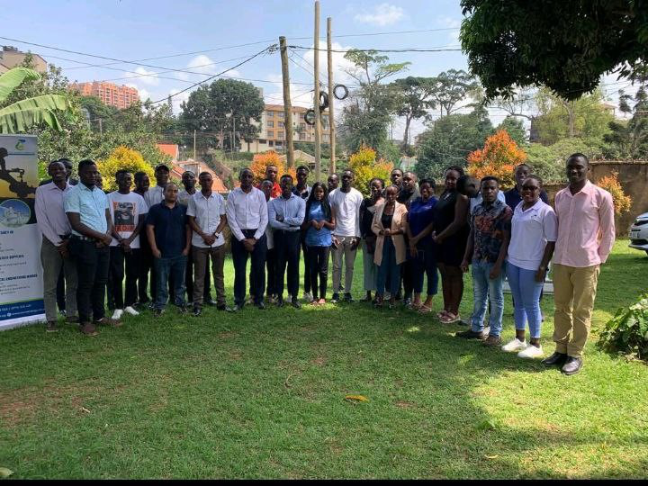

*Figure 20: shows Tarn Energy team with their trainees captured during exposition day too.*

55

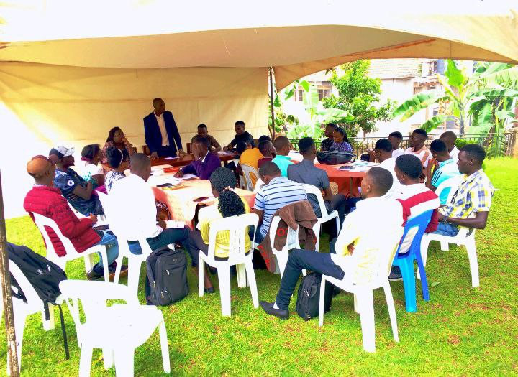

*Figure 21: Mr Musisi Norbert the CEO of Tarn Energy was giving advice to trainees during launch day.*

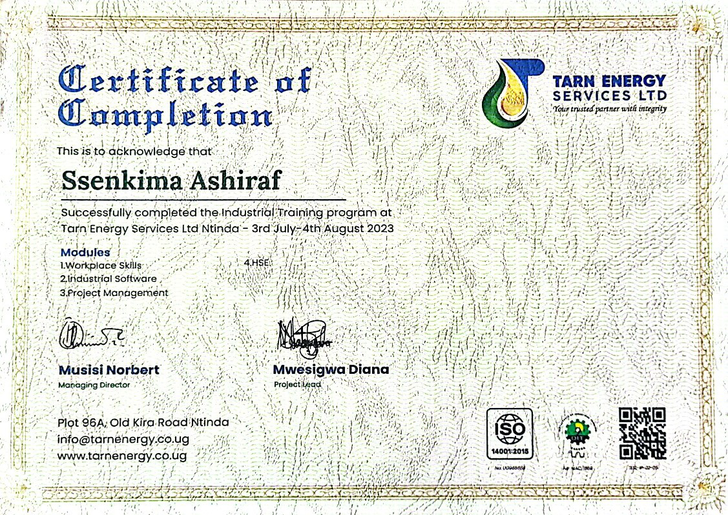

*Figure 22: shows the certificate I got after the training.*

56

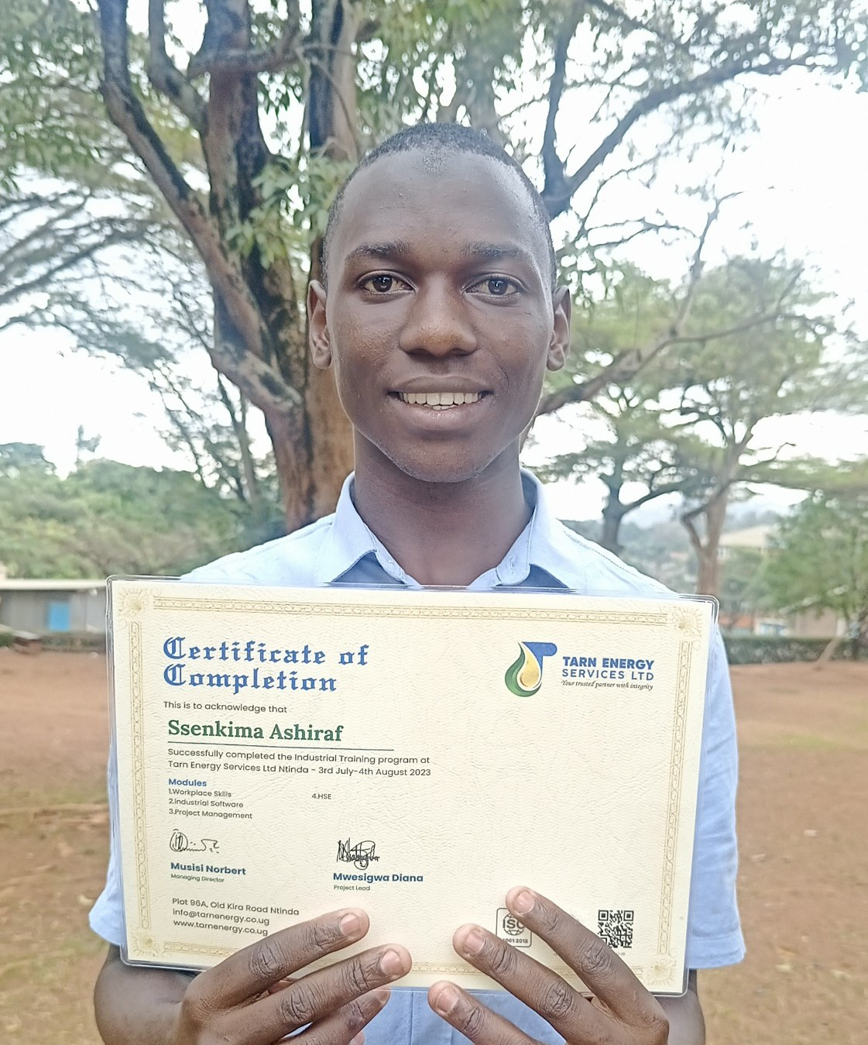

*Figure 23: show me holding the certificate.*

57

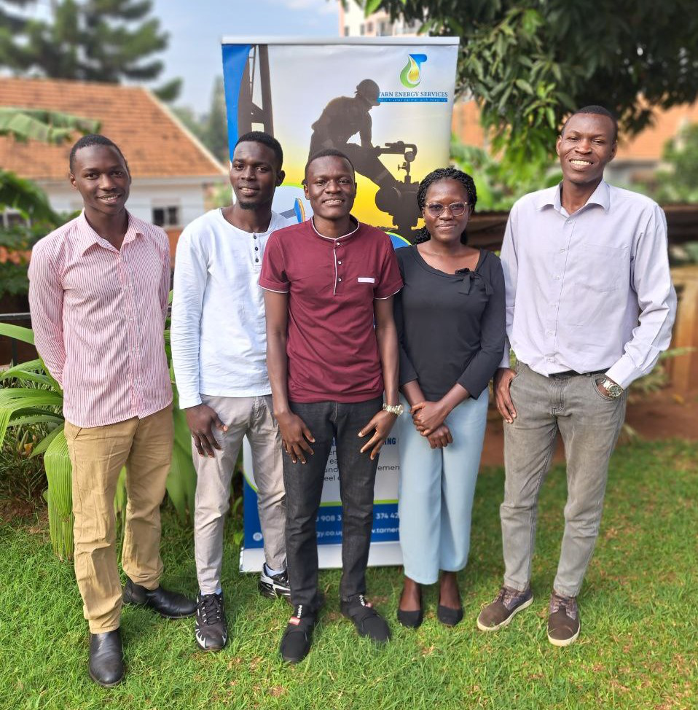

*Figure 24: one of my team members during the training and was also captured during exposition day.*

58



*Figure 25: During awarding certificates, the lady was a chief guest from EACOP and the other guest was from Victoria University.*

59

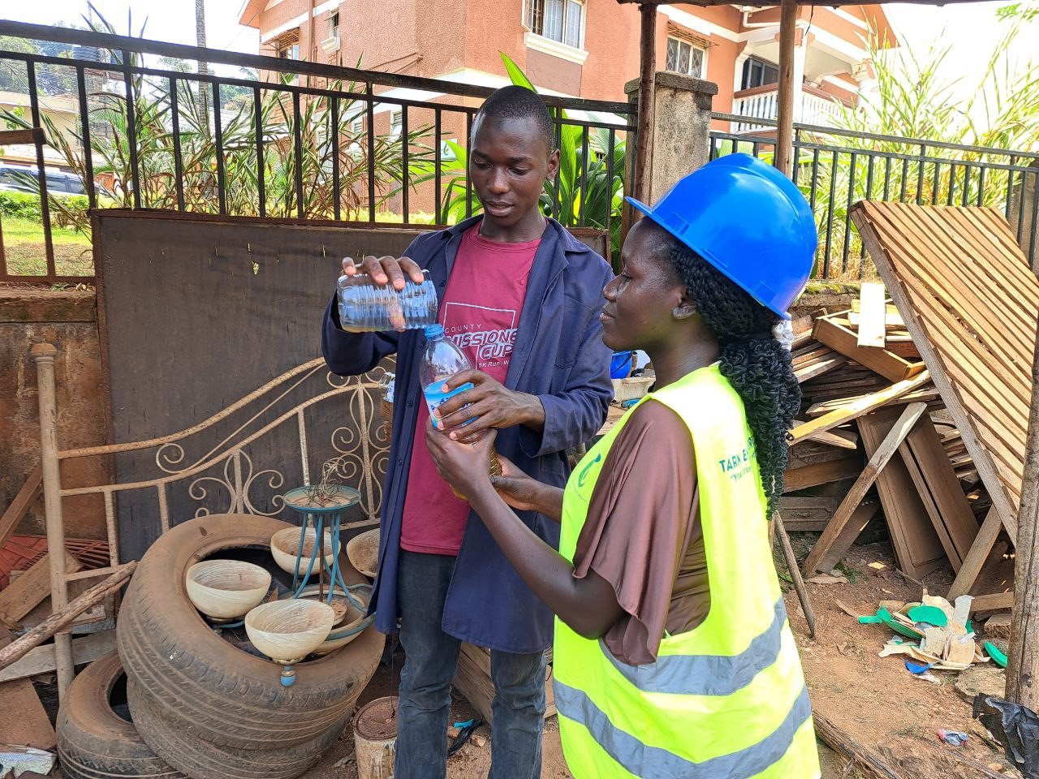

*Figure 26: Was captured during our gasoline experiment.*

60